**Plotting in R – an Introduction using data from the FM Database**

3/8/2016

Zach Lawson, Dan Oele, Gretchen Hansen

**AGENDA**

* Section 1: Plotting in base R
* Section 2: Plotting using ggplot
* Section 3: Making your plots look pretty in ggplot
* Troubleshooting tips and tricks
  + GGplot website <http://ggplot2.org/>
  + R graph catalog <http://shiny.stat.ubc.ca/r-graph-catalog/>
  + Cookbook for R <http://www.cookbook-r.com/>
  + Stack overflow <http://stackoverflow.com/>
  + Google!
* Putting your knowledge to use: assignments or your own data

# R workshop - plotting in R

#FM statewide, March 8, 2016

######################################################################

rm(list = ls()) #removes objects from workspace (starts over)

graphics.off() #turns off all graphics

########################## ##########################

# Load packages

library(fishWiDNR) # for read.FMDB()

library(plyr) # for summarySE()

library(dplyr) # for filter(), select(), mutate(), group_by(), summarize()

require(FSA) # for Summarize(), hist(), expandCounts(), filterD()

library(lubridate) # for month()

library(ggplot2) # for ggplot() and facet wrapping

library(gridExtra) # for tableGrot()

################################################################

#prep data

# Load the Sawyer County FMDB data

setwd("C:/Users/oeled/Documents/R_workshop/2016")

d <- read.FMDB("SAWYER_fish_raw_data_012915.csv",expandCounts=TRUE)

# Remove columns with data that will not be used from here on

d <- select(d,Species1,Waterbody.Name,Gear,Survey.Year,

Mon,Len,Weight.Pounds,Age..observed.annuli.,Gender)

####################################################

# 1 Plotting in Base R

####################################################

# Subset data for clean musky data

MUE <- filterD(d,Species1=="Muskellunge",Len !="NA") # Subset data file for all MUE

#################################################### Histograms

# 1a single plot of single variable

windows()

hist(~Len,data=MUE) # Plot all MUE length data

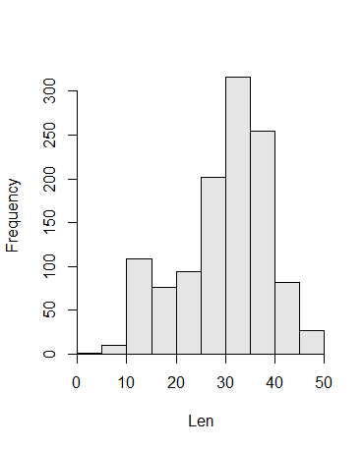

# 1b plotting multiple factors (LF x Year)

windows()

par(mfrow=c(1,5)) # Plotting matrix with 2 rows and 2 columns

MUE10 <- filterD(d,Species1=="Muskellunge",Survey.Year=="2010") # Subset 2010 MUE length data

MUE11 <- filterD(d,Species1=="Muskellunge",Survey.Year=="2011") # Subset 2011 MUE length data

MUE12 <- filterD(d,Species1=="Muskellunge",Survey.Year=="2012") # Subset 2012 MUE length data

MUE13 <- filterD(d,Species1=="Muskellunge",Survey.Year=="2013") # Subset 2013 MUE length data

MUE14 <- filterD(d,Species1=="Muskellunge",Survey.Year=="2014") # Subset 2014 MUE length data

hist(~Len,data=MUE10, main="2010") # Plot 2010 MUE length data

hist(~Len,data=MUE11, main="2011") # Plot 2011 MUE length data

hist(~Len,data=MUE12, main="2012") # Plot 2012 MUE length data

hist(~Len,data=MUE13, main="2013") # Plot 2013 MUE length data

hist(~Len,data=MUE14, main="2014") # Plot 2014 MUE length data

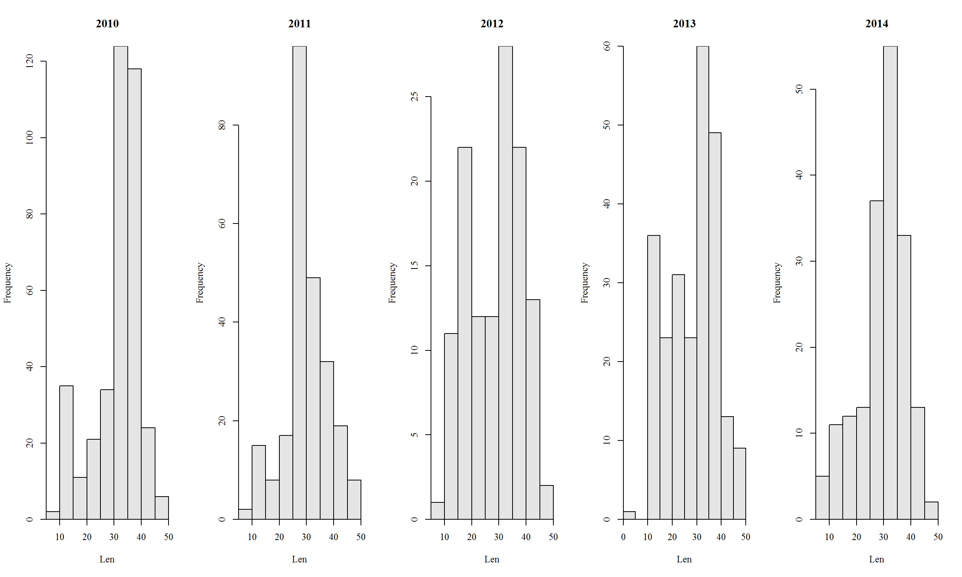

#################################################### Scatterplot

# Subset sturgeon data

sturgeon_weights<- data.frame(filterD(d,Weight.Pounds > 0, Survey.Year !="2014",Weight.Pounds != "NA",Species1=="Lake Sturgeon"))

# 1c

windows()

plot(Weight.Pounds ~ Len,data=sturgeon_weights) # Plot all sturgeon length-weight data

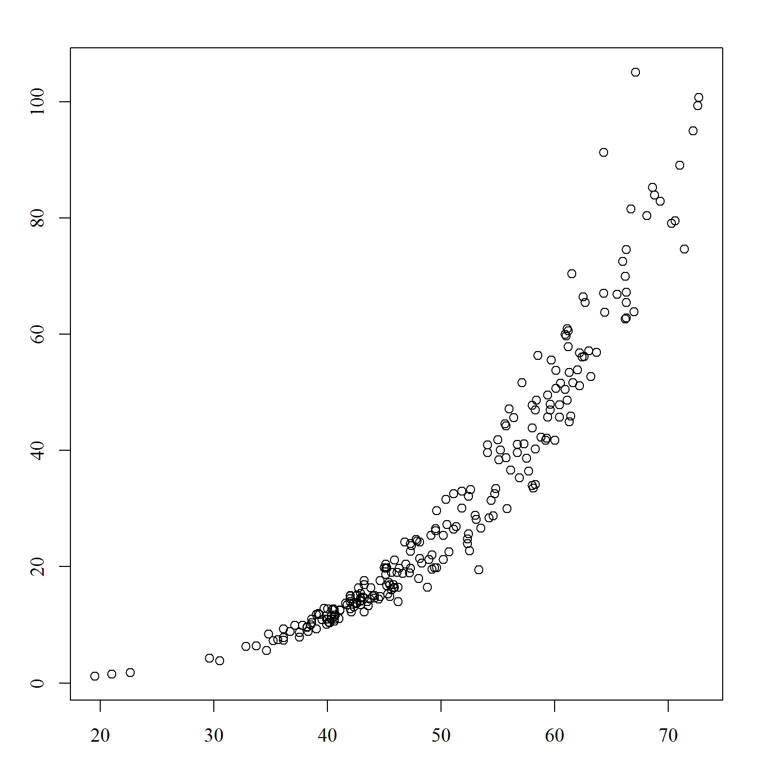

# 1d

windows()

par(mfrow=c(2,2)) # Plotting matrix with 2 rows and 2 columns

sturgeon_lw_10 <- filterD(sturgeon_weights,Survey.Year=="2010") # Subset for 2010 L-W data

sturgeon_lw_11 <- filterD(sturgeon_weights,Survey.Year=="2011") # Subset for 2011 L-W data

sturgeon_lw_12 <- filterD(sturgeon_weights,Survey.Year=="2012") # Subset for 2012 L-W data

sturgeon_lw_13 <- filterD(sturgeon_weights,Survey.Year=="2013") # Subset for 2013 L-W data

plot(Weight.Pounds ~ Len,data=sturgeon_lw_10,main="2010") # Plot 2010 L-W data

plot(Weight.Pounds ~ Len,data=sturgeon_lw_11,main="2011") # Plot 2011 L-W data

plot(Weight.Pounds ~ Len,data=sturgeon_lw_12,main="2012") # Plot 2012 L-W data

plot(Weight.Pounds ~ Len,data=sturgeon_lw_13,main="2013") # Plot 2013 L-W data

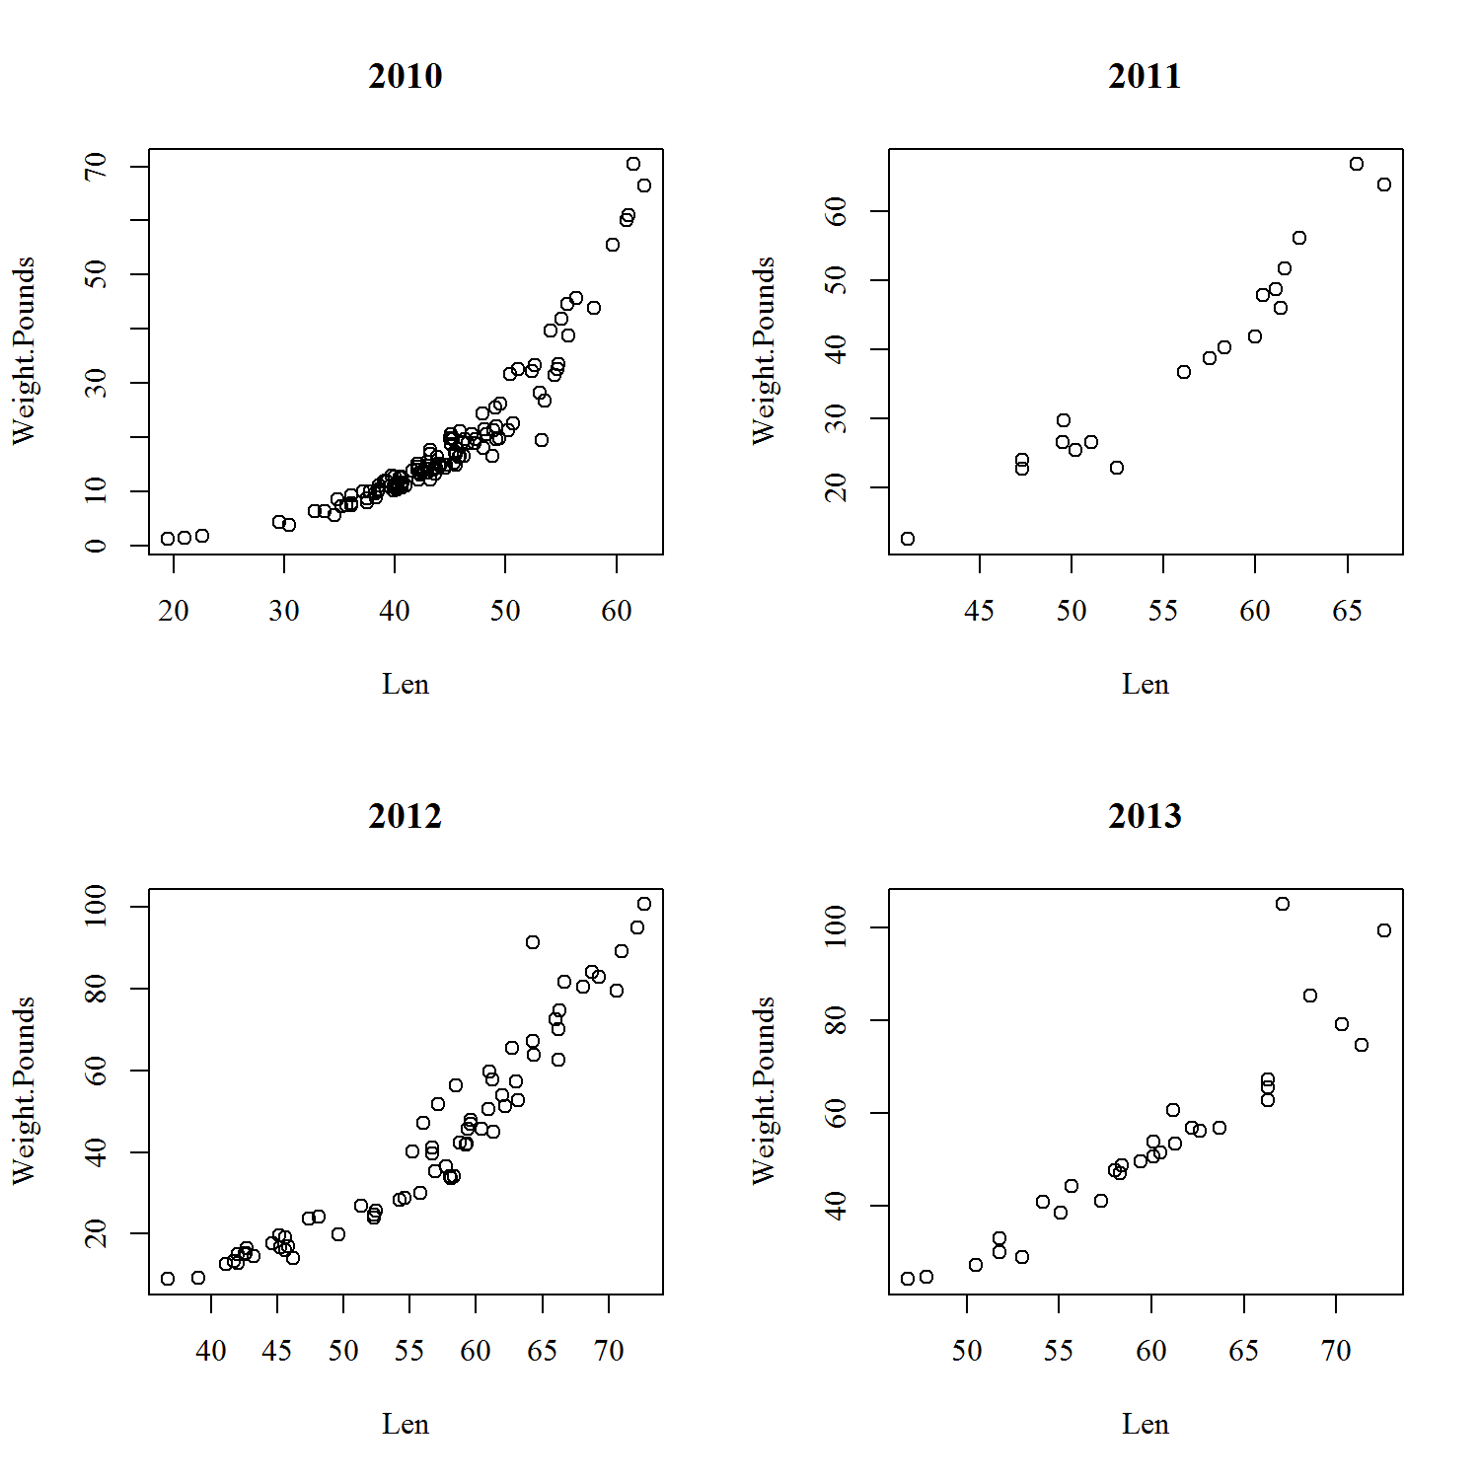

###################################################

#Section 2 – plotting in ggplot()

# Simple object plotting GGplot() - similar to BaseR just a different approach (and more efficient for multiple factors)

####################################################

MUE <- filterD(d,Species1=="Muskellunge",Len !="NA") # subset datafram for muskellunge, exclude those values in Len that are NA's

#################################################### Histograms

#2a plotting L-F histogram

ggplot(data=MUE, aes(Len)) + # set up basic ggplot structure

geom_histogram(binwidth = 5) # tell ggplot what kind of plot to make and how many bins

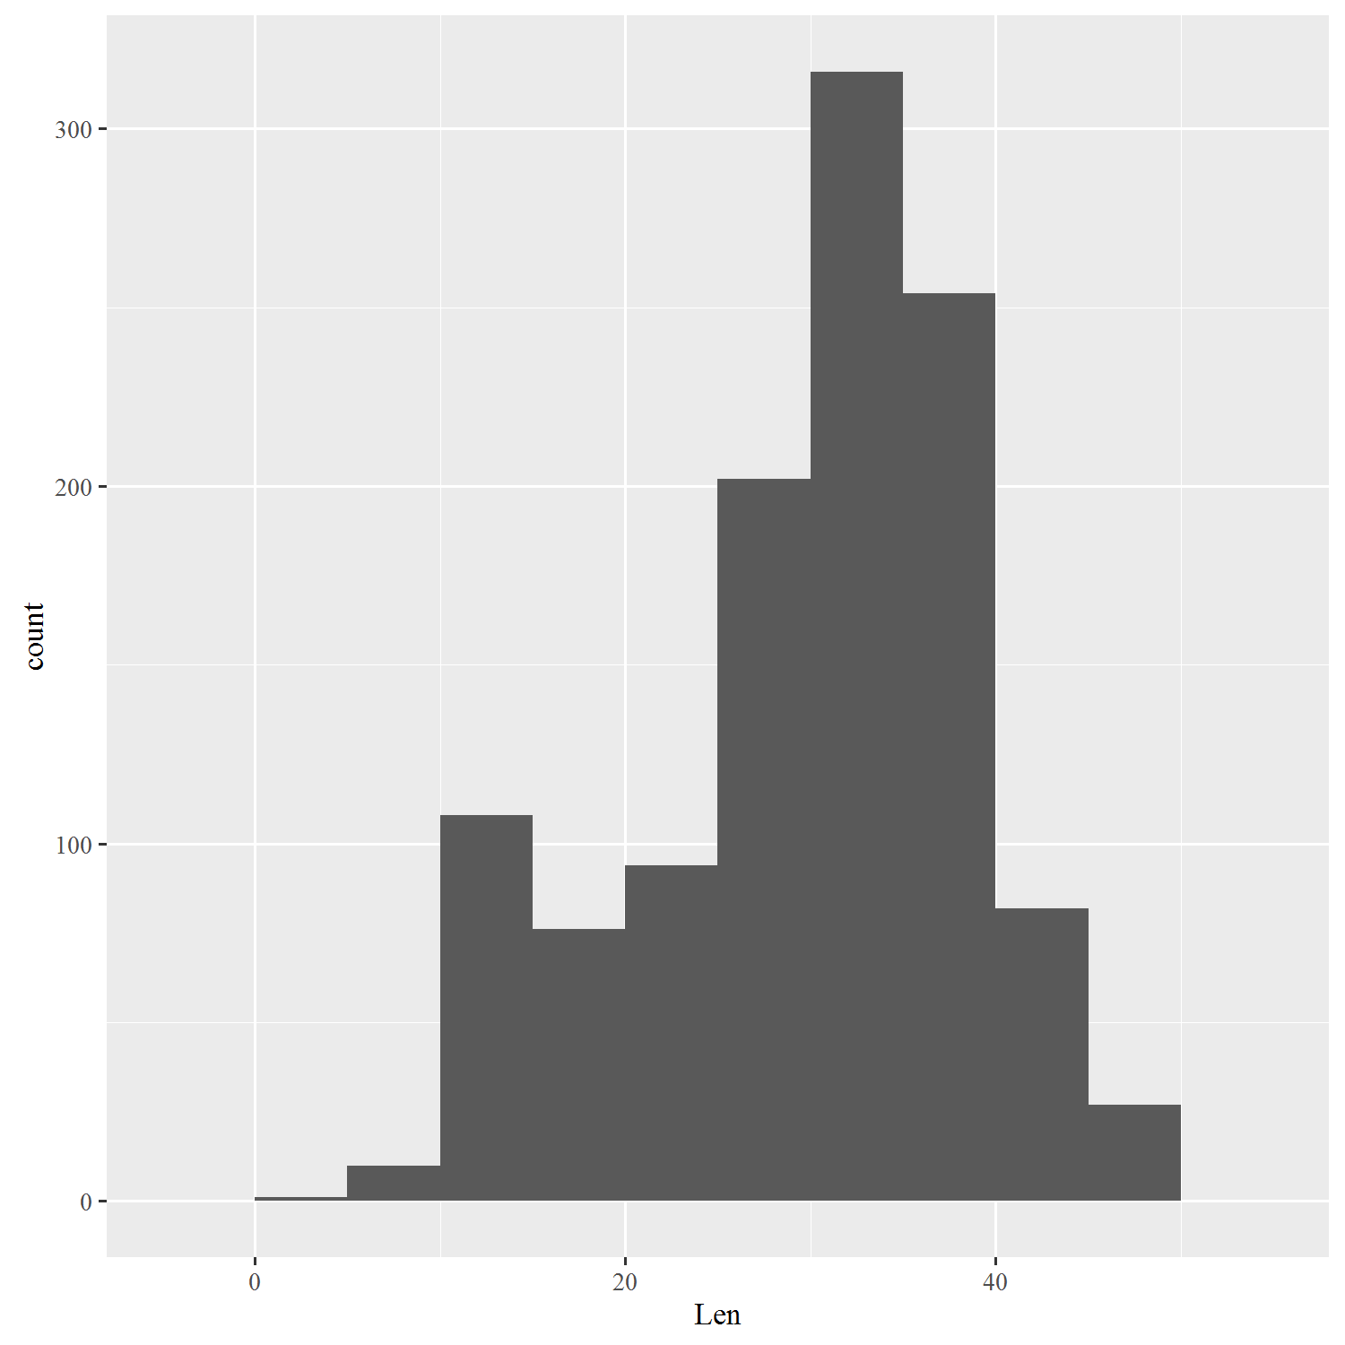

#2b plotting L-F histogram 'object'

# set up basic ggplot structure and object based plotting

MUE_histogram<-ggplot(data=MUE, aes(Len)) +

geom_histogram(binwidth = 5)

MUE_histogram # call the name of the ggplot to see it



################################################### Boxplots

#2c Plotting length distributions using boxplots instead of histogram

MUE_Length_boxplot<-ggplot(data=MUE, aes(as.factor(Survey.Year),Len)) +

geom_boxplot()

MUE_Length_boxplot

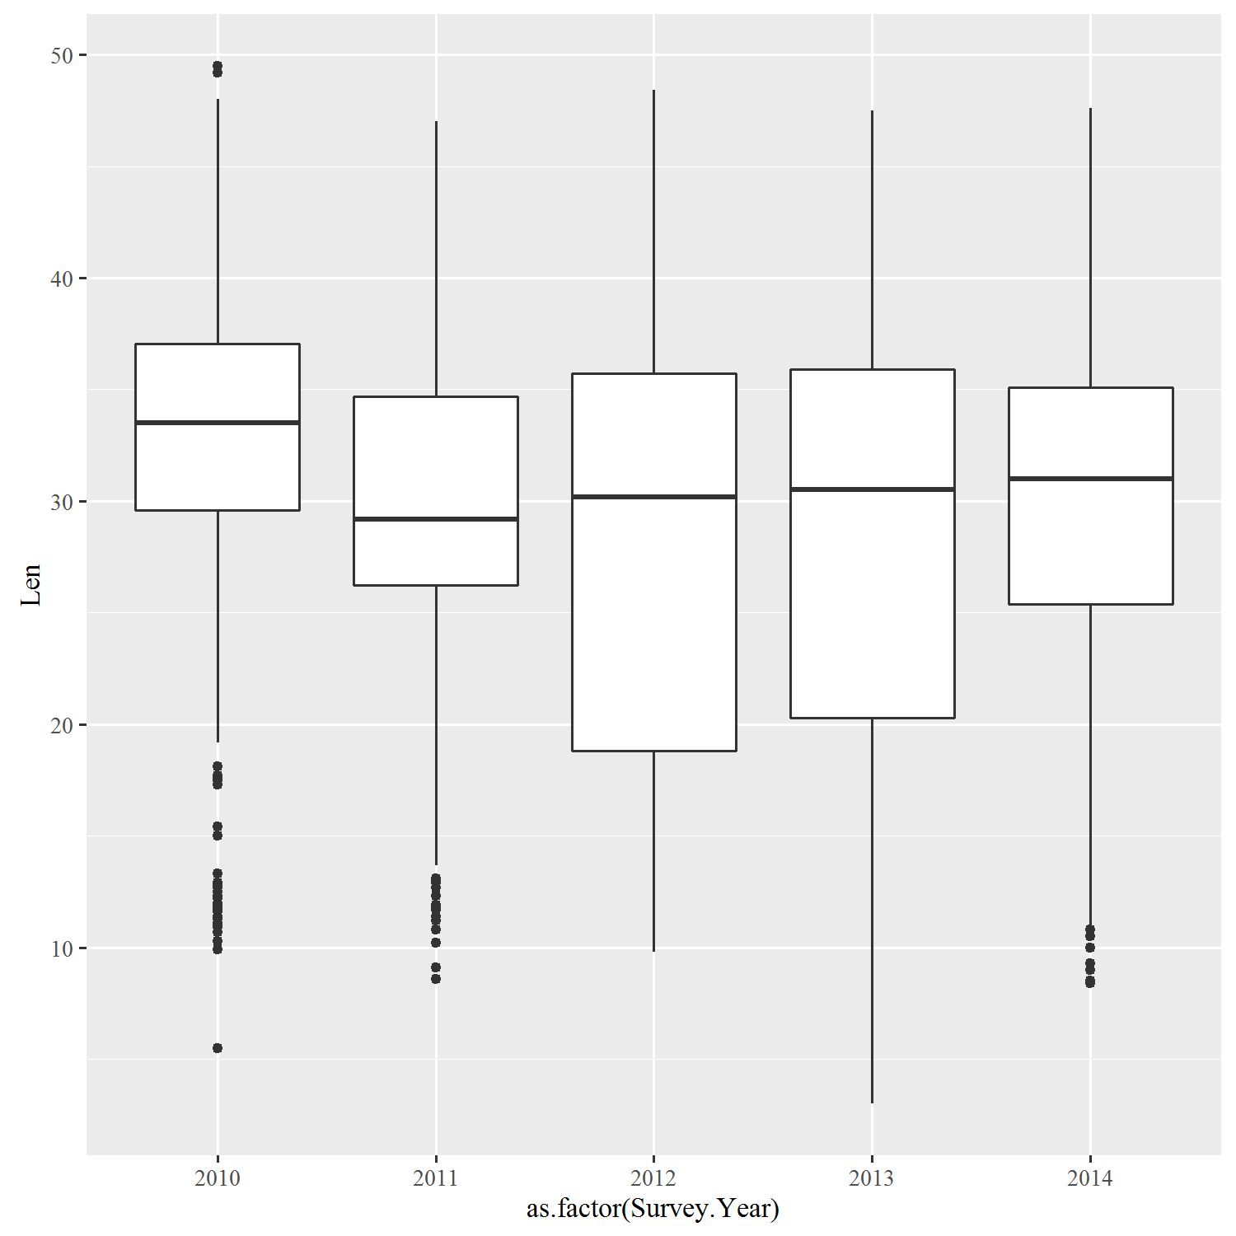

################################################### Scatterplots

# Subset data to get clean lake sturgeon L-W data

sturgeon_weights<- data.frame(filterD(d,Weight.Pounds > 0, Survey.Year !="2014",Weight.Pounds != "NA",Species1=="Lake Sturgeon"))

#2d Simple X-Y plotting 2 factor (Length, Weight)

windows()

L_vs_W<- ggplot(data=sturgeon_weights, aes(x=Len,y=Weight.Pounds))+

geom_point()

L_vs_W

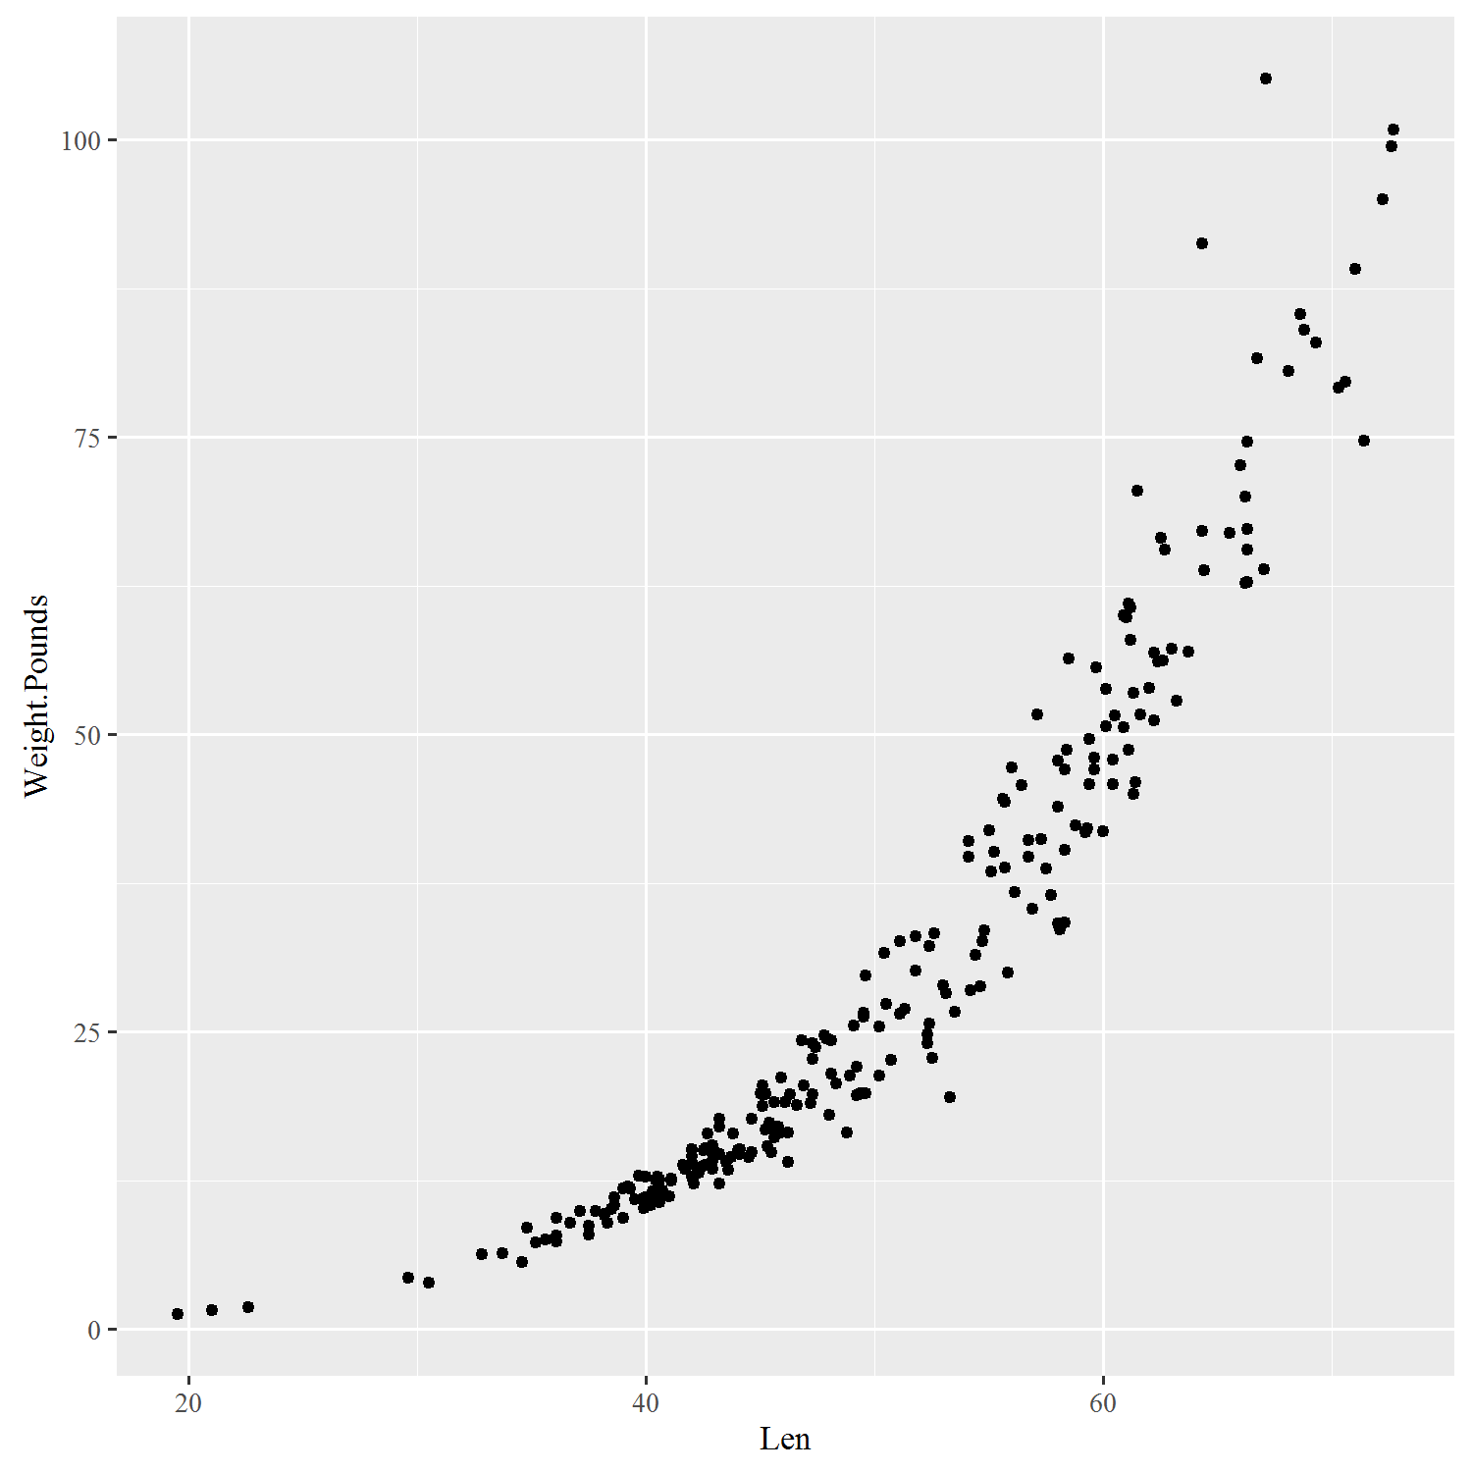

#2e X-Y plotting, 3 factor (Length, Weight, Year)

windows()

L_vs_W_year<- ggplot(data=sturgeon_weights, aes(x=Len,y=Weight.Pounds)) +

geom_point()+

facet_wrap( ~ Survey.Year)

L_vs_W_year

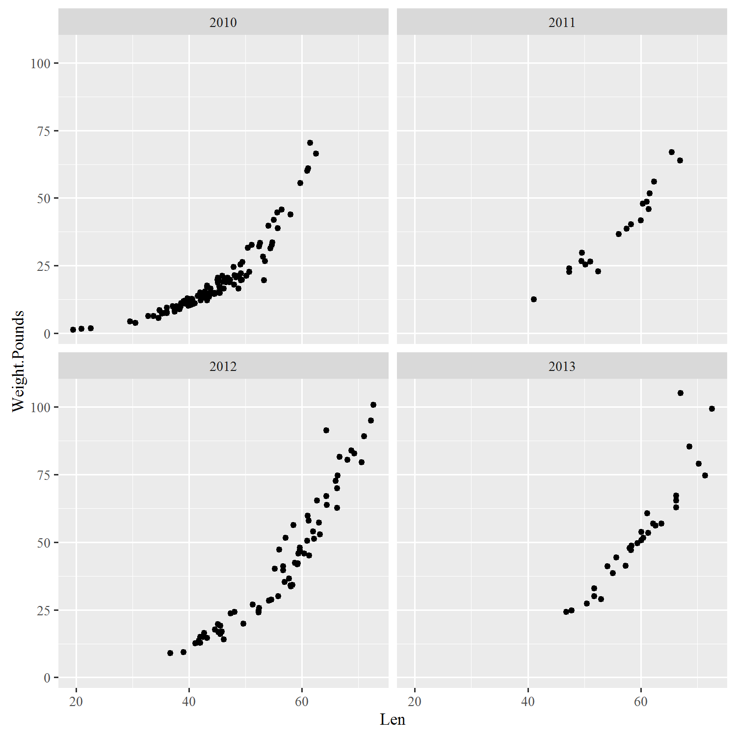

#2f X-Y plotting, 4 factor (Length x Weight x Year x Waterbody) (done using 'colour')

windows()

L_vs_W_year_waterbody<- ggplot(data=sturgeon_weights, aes(x=Len,y=Weight.Pounds,colour=Waterbody.Name)) +

geom_point()+

facet_wrap(~Survey.Year)

L_vs_W_year_waterbody

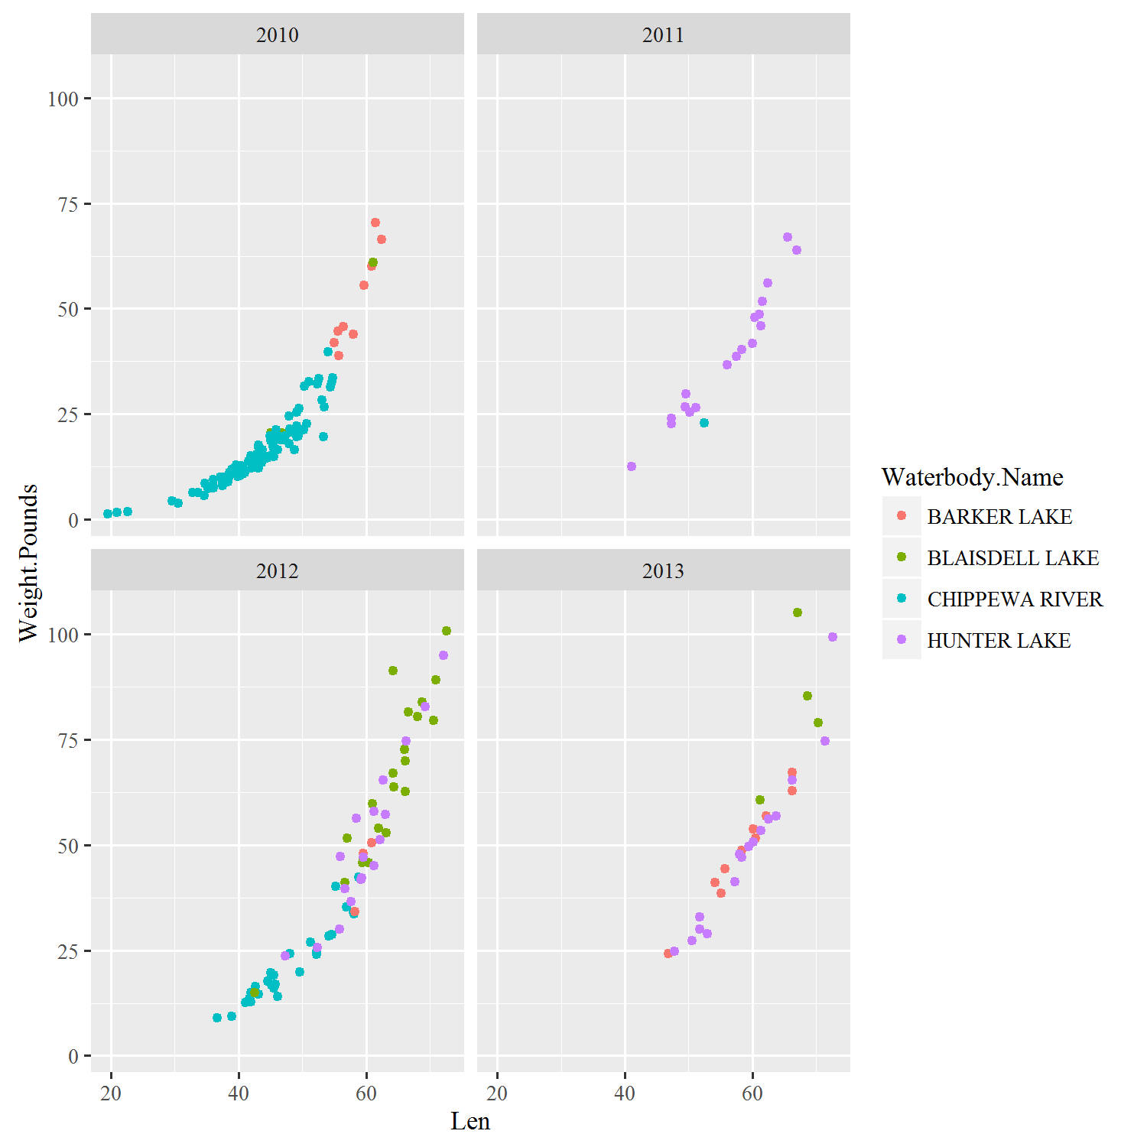

#2g X-Y plotting, 4 factor (Length x Weight x Waterbody x Year) (done using 'shape')

windows()

L_vs_W_year_waterbody2<- ggplot(data=sturgeon_weights, aes(x=Len,y=Weight.Pounds,shape=Waterbody.Name)) +

geom_point()+

facet_wrap(~Survey.Year)

L_vs_W_year_waterbody2

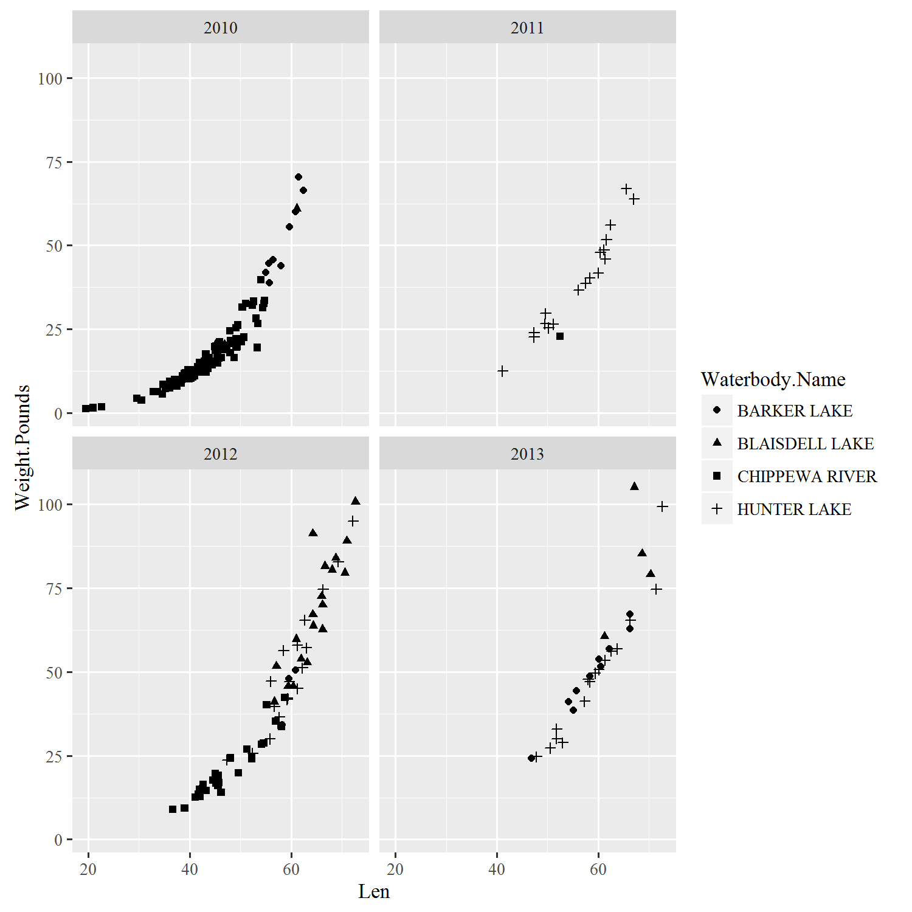

################################################### Scatterplot + regression line

#2h (similar to 2c) Simple X-Y plotting 2 factor (Length, Weight) with regression line

windows()

sturg_LW<-ggplot(data=sturgeon_weights, aes(x=Len,y=Weight.Pounds))+

geom_point()+

stat_smooth(method = "loess",se=F,fullrange=F,color='black')

sturg_LW

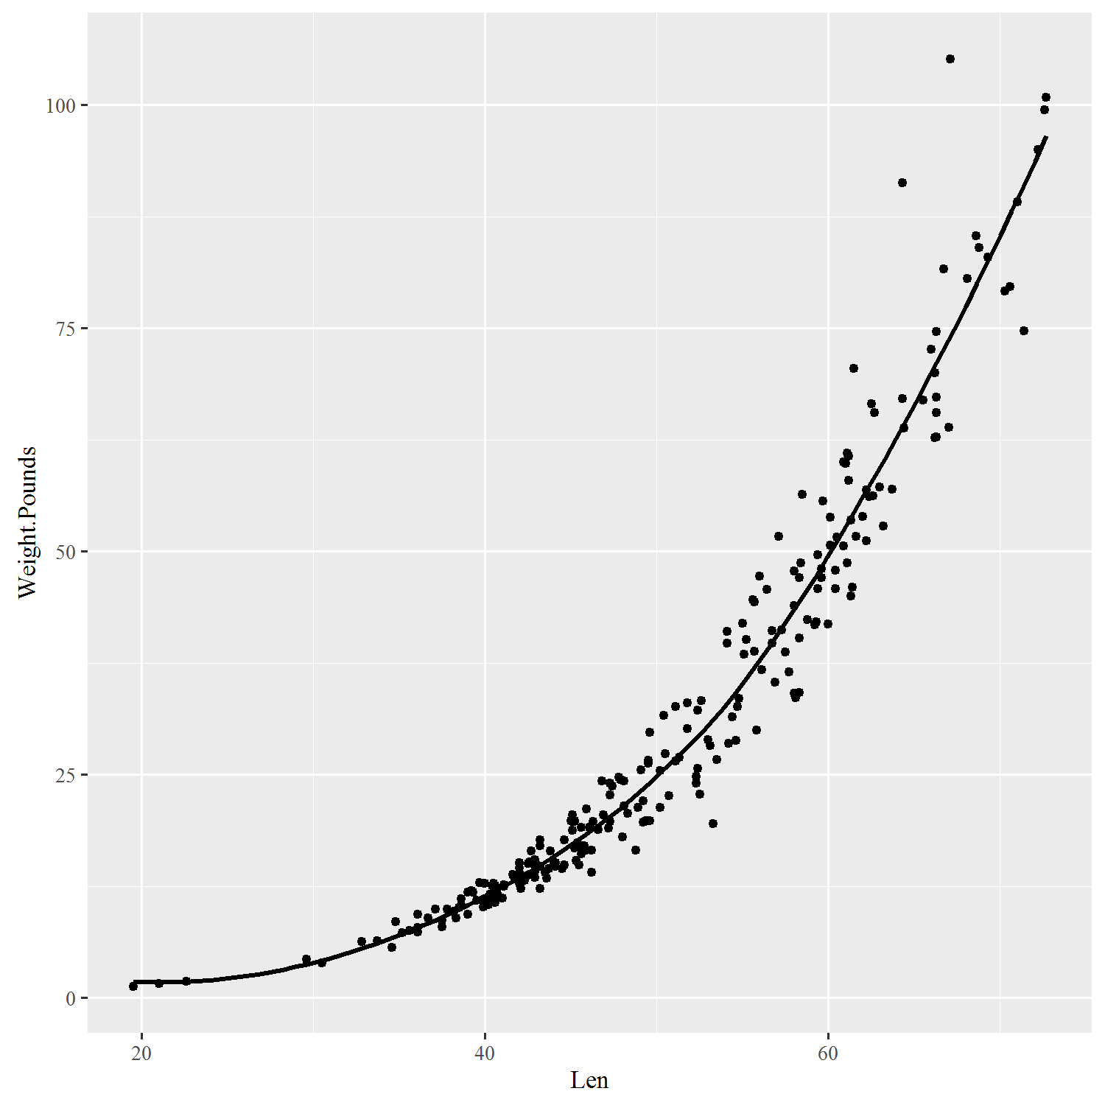

#########################################################################

#3. Aesthetics in ggplot - making your plots pretty

##########################################################################

# Remember 2f: X-Y plotting, 4 factor (Length x Weight x Year x Waterbody) (done using 'colour')

windows()

L_vs_W_year_waterbody<- ggplot(data=sturgeon_weights, aes(x=Len,y=Weight.Pounds,colour=Waterbody.Name)) + geom_point()+ facet_wrap(~Survey.Year)

L_vs_W_year_waterbody



############### basic appearance ####################

#3A change "theme" using built in commands

windows()

L_vs_W_year_waterbody<-L_vs_W_year_waterbody + theme_bw()

print(L_vs_W_year_waterbody)

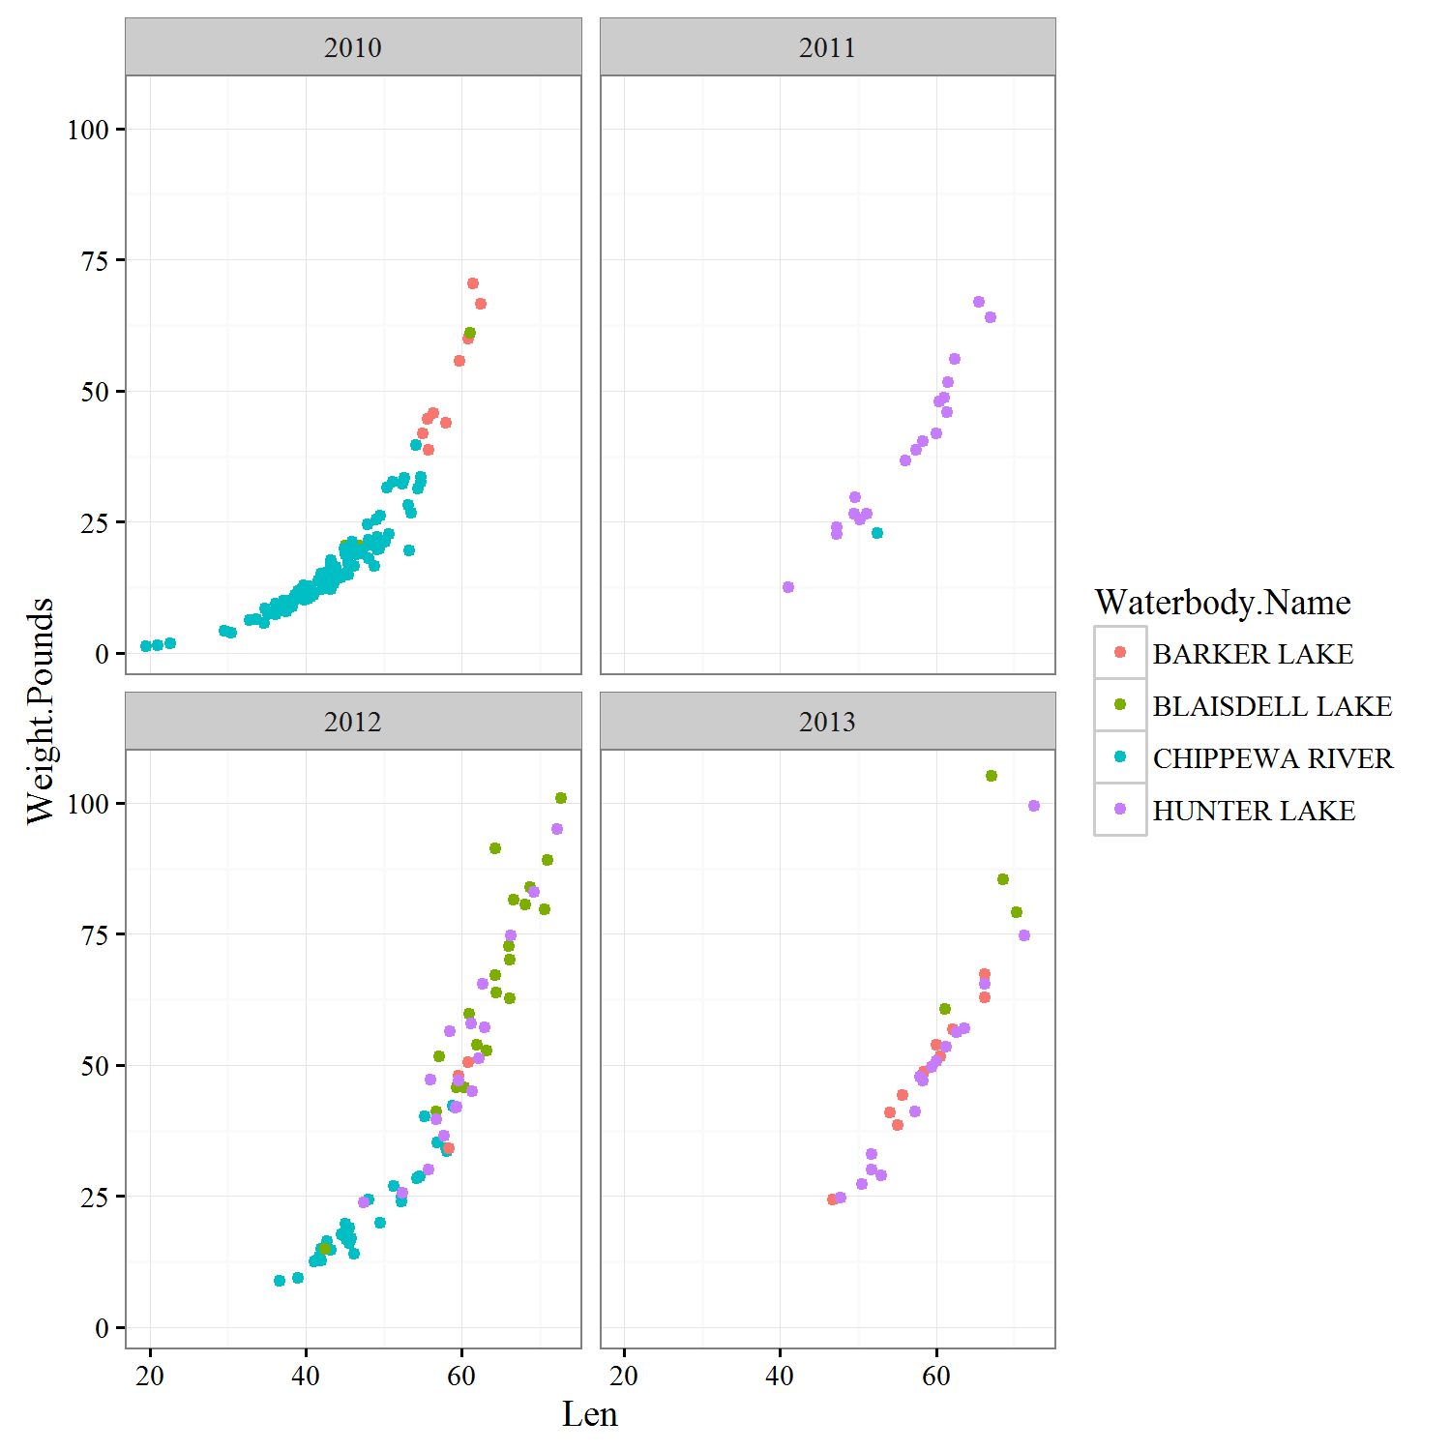

#3B change "theme" elements manually

windows()

L_vs_W_year_waterbody<-L_vs_W_year_waterbody +

theme(axis.title=element_text(size=16, face="bold"), #works on both axes; change axes independently #using axis.title.x and axis.title.y

axis.text=element_text(size=14), #works on both axes; change axes independently using axis.text.x #and axis.text.y

strip.text.x=element_text(size=16, face="bold"), #changes text of facet box titles

panel.grid.major = element_line(colour=NA), #removes major gridlines

panel.grid.minor = element_line(colour = NA), #removes minor gridlines

panel.background = element_rect(colour = NA), #removes fill color from plot background

strip.background=element_blank() ) #removes fill color from facet box titles

print(L_vs_W_year_waterbody)

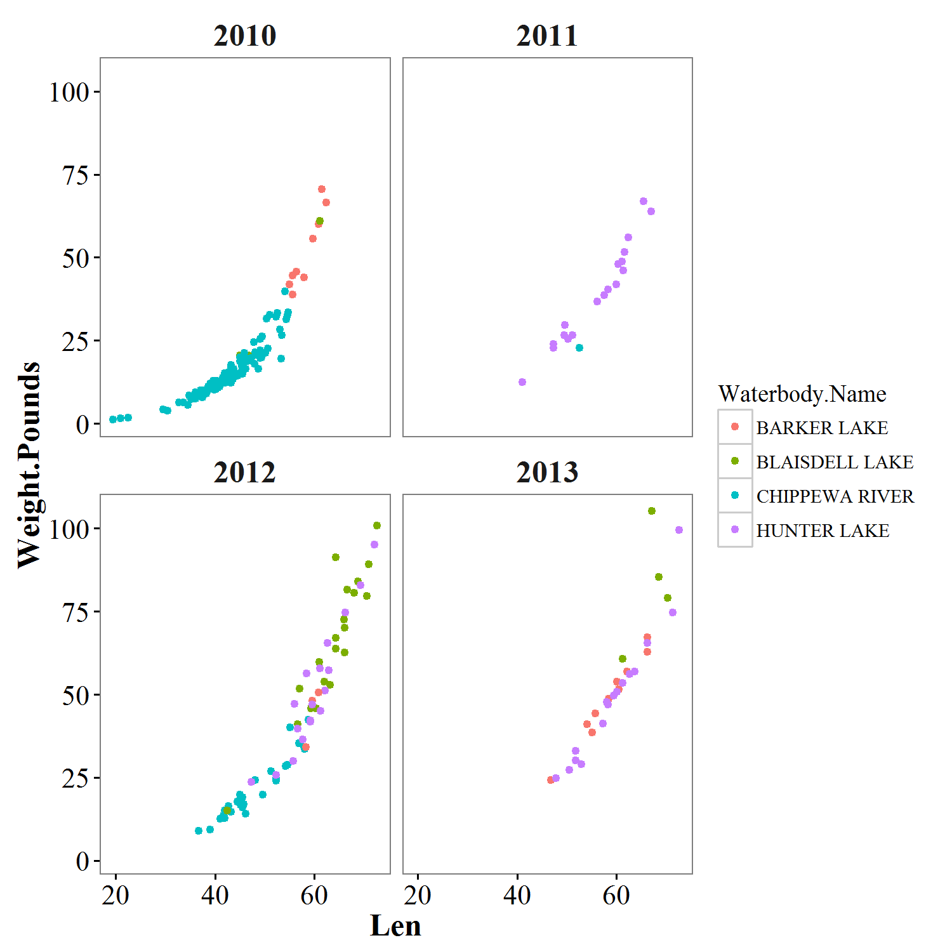

#it is possible to change any aspect of a plot in ggplot

#list of plot aspects you can change using theme: http://docs.ggplot2.org/current/theme.html

############### Changing or adding text ####################

#3C Changing axis labels

windows()

L_vs_W_year_waterbody6<- L_vs_W_year_waterbody+ xlab("Length (in)")+ylab("Weight (lbs)")

print(L_vs_W_year_waterbody)

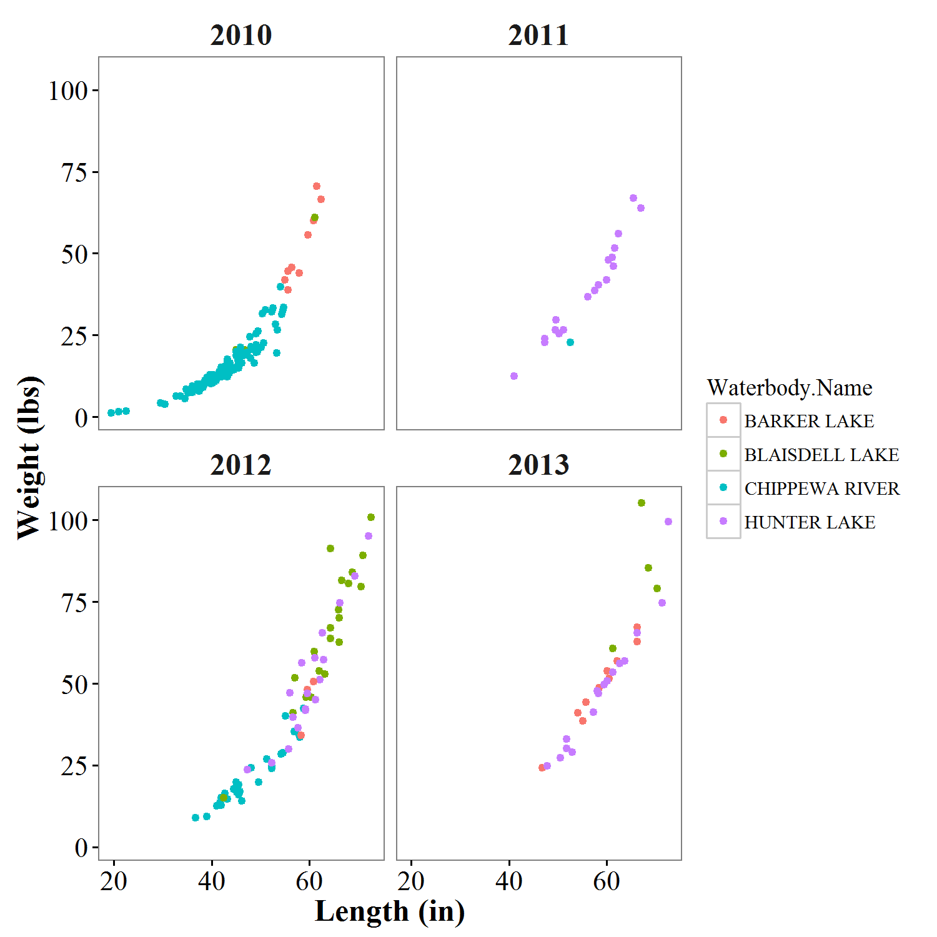

#3C.2 changing axis labels - wrapping text onto two lines

windows()

L_vs_W_year_waterbody.test<- L_vs_W_year_waterbody+

xlab("Fish total length from\nfour favorite water bodies")+ylab("Weight (lbs)")

print(L_vs_W_year_waterbody.test)

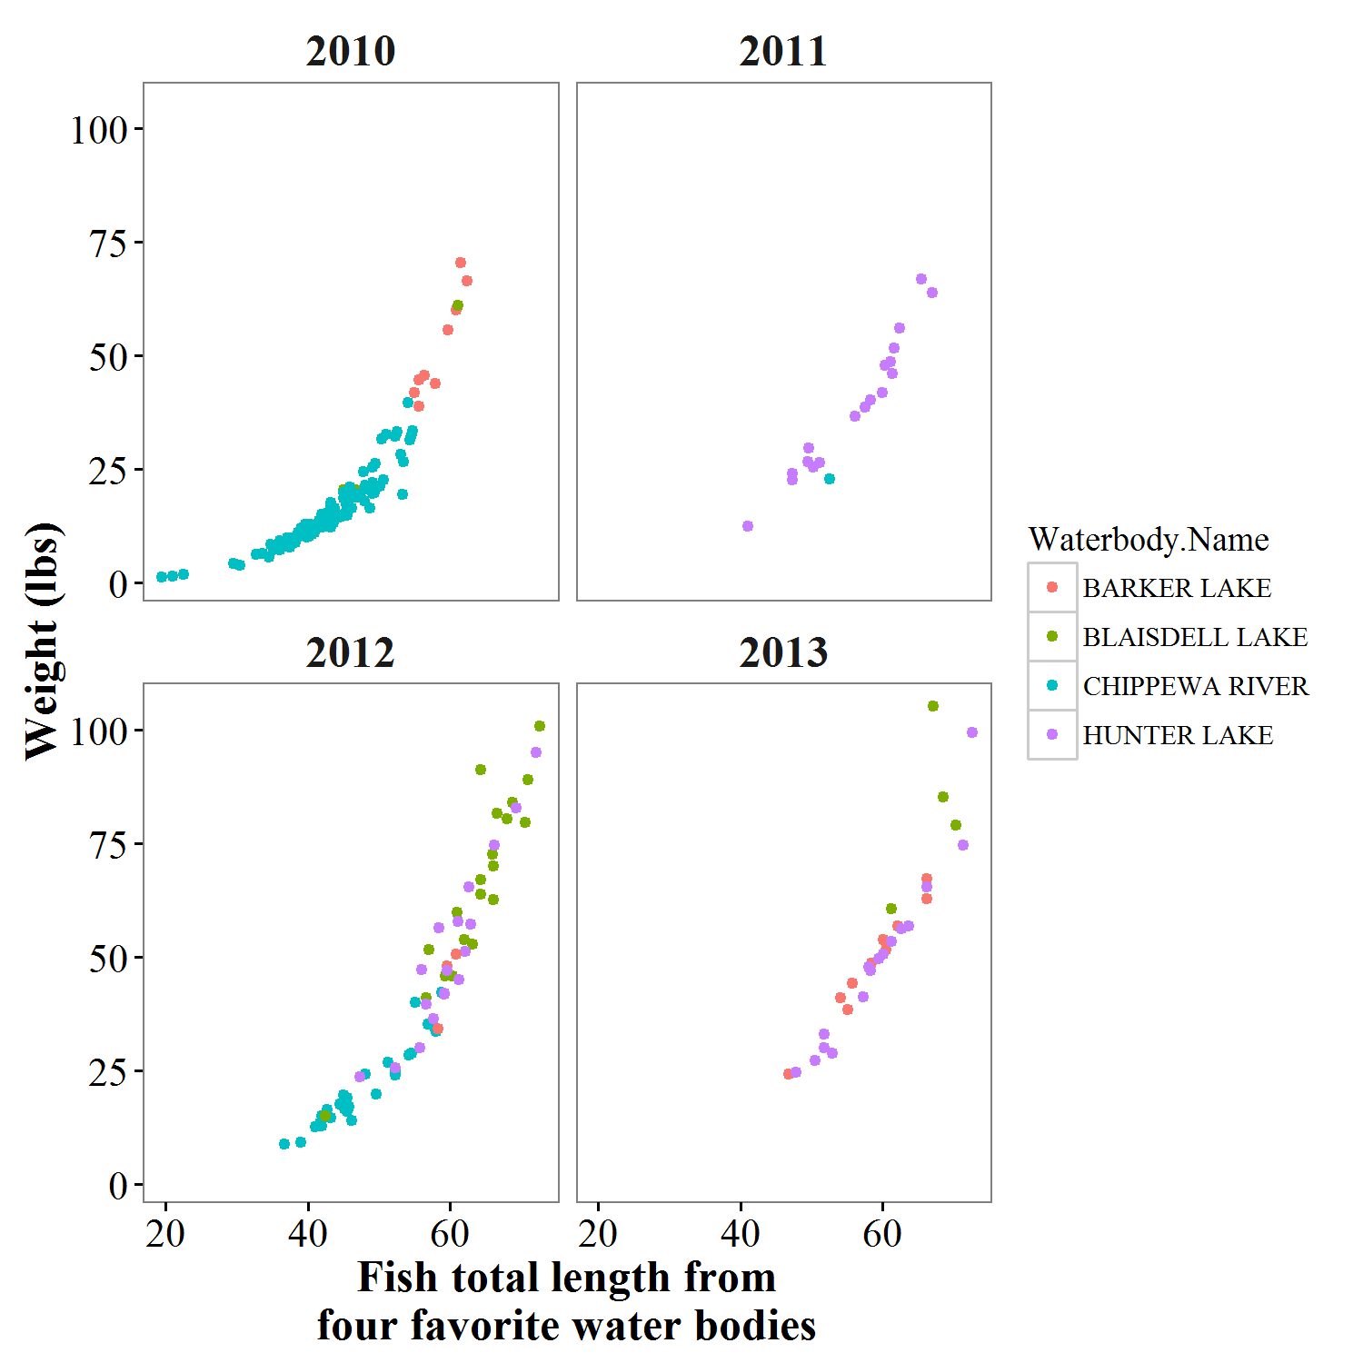

#see extra "bonus" code for adding symbols, subscripts, etc to axis labels

############################# Colors and shapes ########################################

#3D changing colors using built in functions

#color brewer for discrete values

windows()

L_vs_W_year_waterbody<- L_vs_W_year_waterbody +

scale_colour_brewer(palette="Set1") #colour_brewer is one of many built in colour functions. "set1" is #one of many palettes.

print(L_vs_W_year_waterbody)

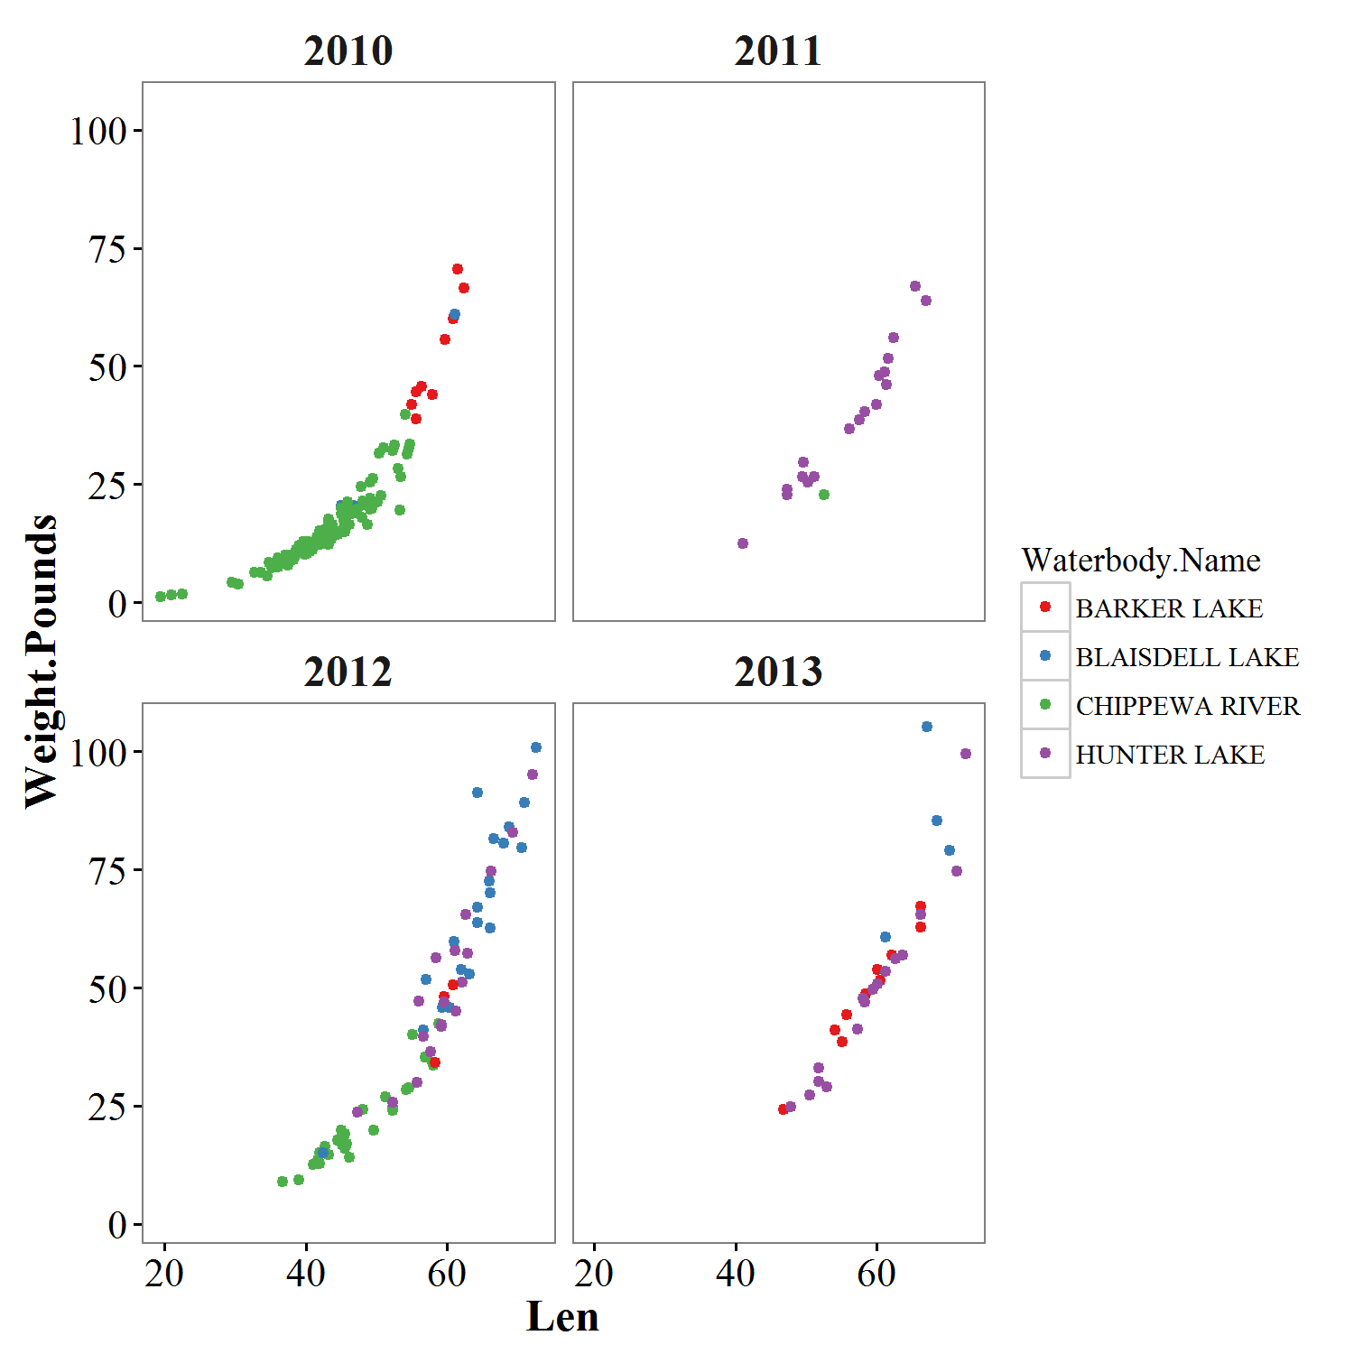

#see http://docs.ggplot2.org/current/scale_brewer.html

#and https://www.nceas.ucsb.edu/~frazier/RSpatialGuides/colorPaletteCheatsheet.pdf

# and <http://colorbrewer2.org/> for ideas, tips, and color palettes.

#3E changing colors manually

windows()

L_vs_W_year_waterbody<- L_vs_W_year_waterbody +

scale_colour_manual(values=c("blue4", "darkgoldenrod1", "darkturquoise", "purple1")) #could be any #colours

print(L_vs_W_year_waterbody)

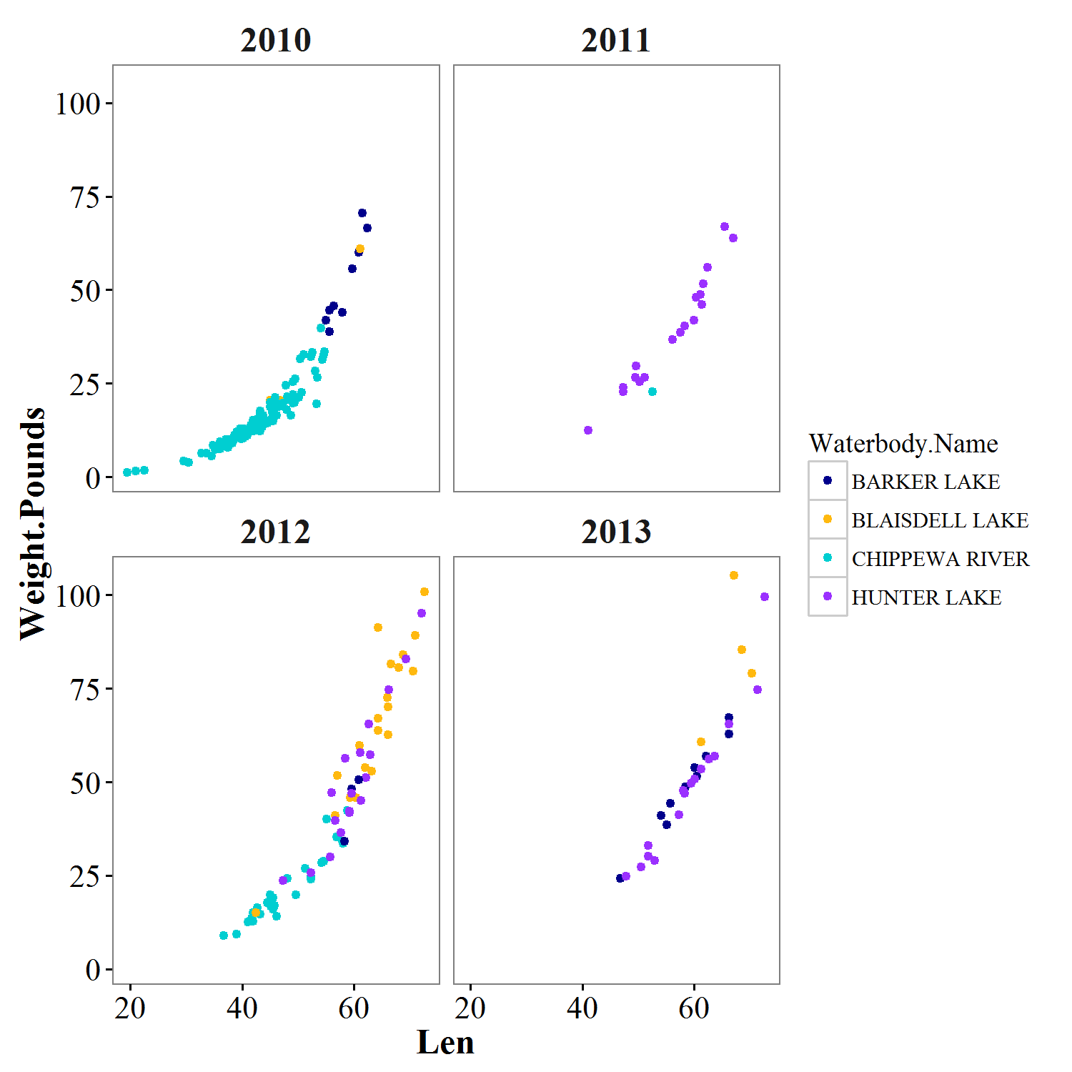

#3F changing shapes - using shape instead of colour for waterbody name, as in

#2g X-Y plotting, 4 factor (Length x Weight x Waterbody x Year) (done using 'shape')

#note that we also have to change other aesthetics to make it pretty

windows()

L_vs_W_year_waterbody2<- L_vs_W_year_waterbody2+ scale_shape_manual(values=c(1,16,15,17))+

theme_bw()+

theme(axis.title=element_text(size=16, face="bold"),

axis.text=element_text(size=14),

strip.text.x=element_text(size=16, face="bold"),

panel.grid.major = element_line(colour=NA),

panel.grid.minor = element_line(colour = NA),

panel.background = element_rect(colour = NA),

strip.background=element_blank() )

print(L_vs_W_year_waterbody2)

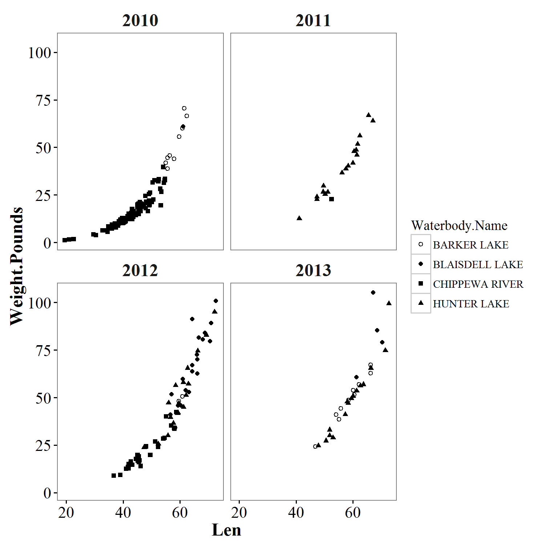

#3G changing size of points

#THIS WON'T WORK (AT LEAST NOT THE WAY WE INTEND)

#this will add another set of points on top of existing set

windows()

L_vs_W_year_waterbody<- L_vs_W_year_waterbody+geom_point(size=4)

print(L_vs_W_year_waterbody)

#Instead, reset object with full set of code

windows()

L_vs_W_year_waterbody<- ggplot(data=sturgeon_weights, aes(x=Len,y=Weight.Pounds,colour=Waterbody.Name)) +

geom_point(size=4)+

facet_wrap(~Survey.Year)+

scale_colour_manual(values=c("blue4", "darkgoldenrod1", "darkturquoise", "purple1"))+

xlab("Length (in)")+ylab("Weight (lbs)")+

theme_bw()+

theme(axis.title=element_text(size=16, face="bold"),

axis.text=element_text(size=14),

strip.text.x=element_text(size=16, face="bold"),

panel.grid.major = element_line(colour=NA),

panel.grid.minor = element_line(colour = NA),

panel.background = element_rect(colour = NA),

strip.background=element_blank() )

print(L_vs_W_year_waterbody)

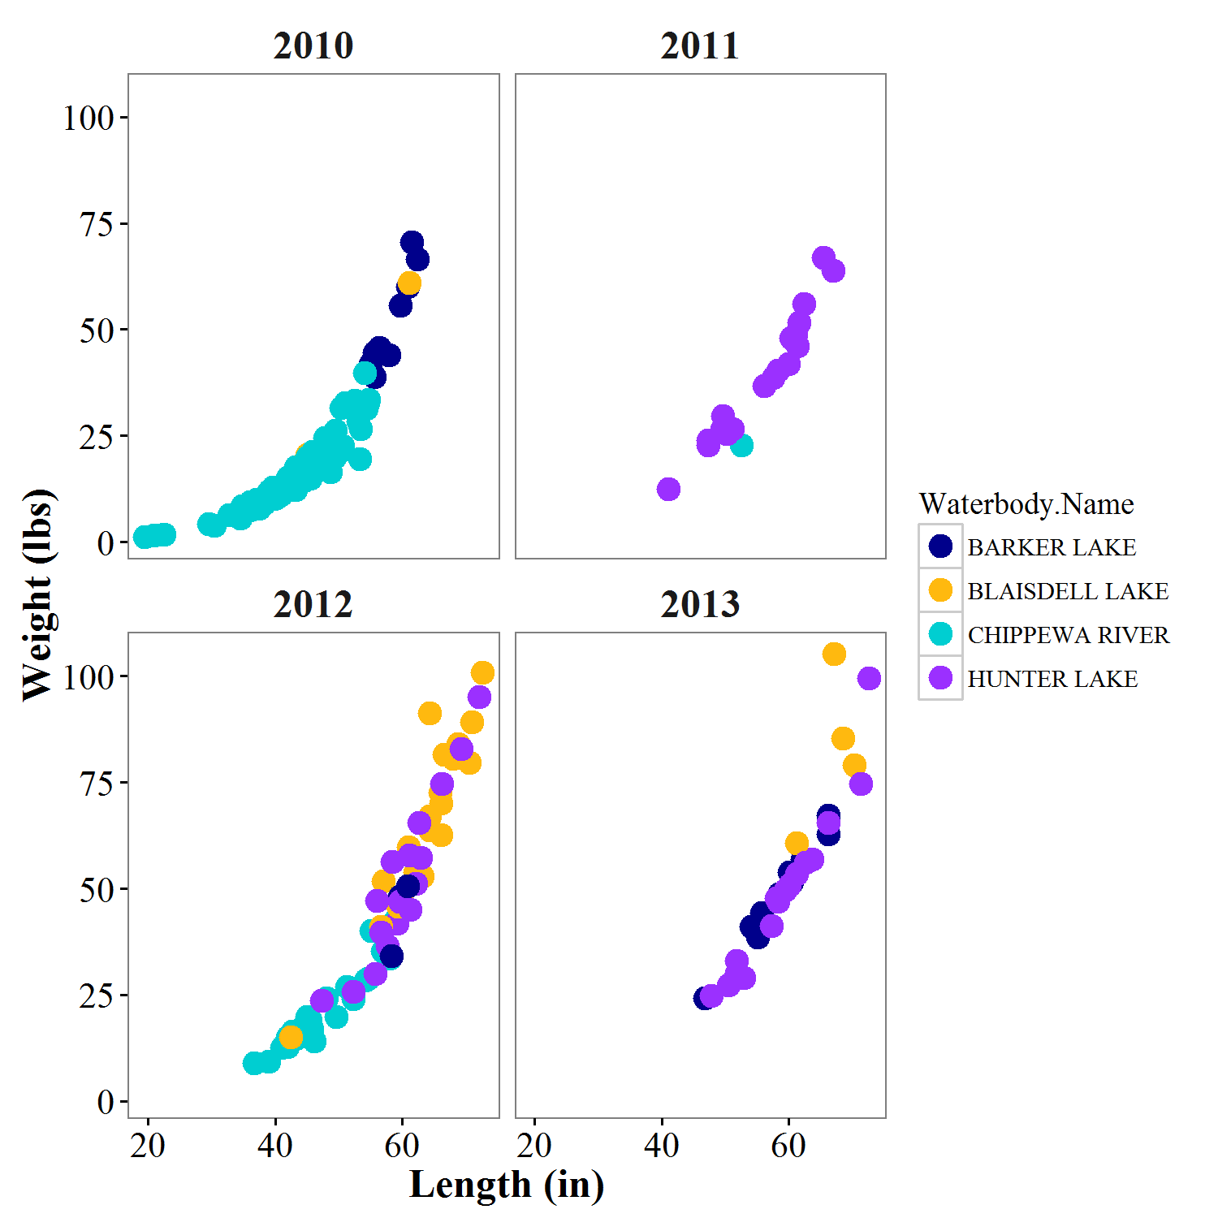

#3H make points see-through so you can better see overlapping points

windows()

L_vs_W_year_waterbody<- ggplot(data=sturgeon_weights, aes(x=Len,y=Weight.Pounds,colour=Waterbody.Name)) +

geom_point(size=4, alpha=.5)+ #alpha changes transparency of points, ranges from 0-1

facet_wrap(~Survey.Year)+

scale_colour_manual(values=c("blue4", "darkgoldenrod1", "darkturquoise", "purple1"))+

xlab("Length (in)")+ylab("Weight (lbs)")+

theme_bw()+

theme(axis.title=element_text(size=16, face="bold"),

axis.text=element_text(size=14),

strip.text.x=element_text(size=16, face="bold"),

panel.grid.major = element_line(colour=NA),

panel.grid.minor = element_line(colour = NA),

panel.background = element_rect(colour = NA),

strip.background=element_blank() )

print(L_vs_W_year_waterbody)

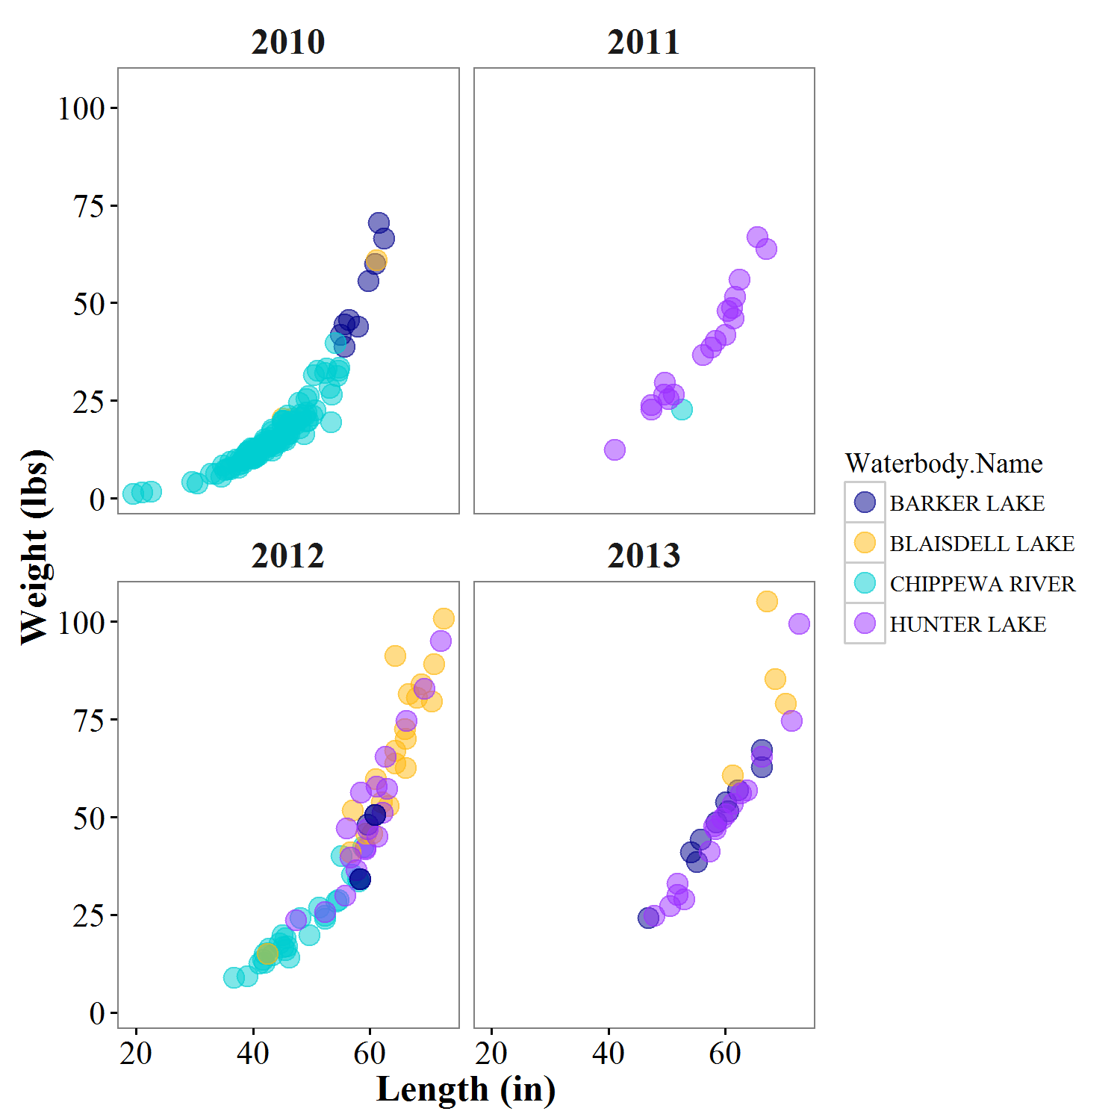

#3I change size as function of variable

windows()

L_vs_W_year_waterbody_test2<- ggplot(data=sturgeon_weights, aes(x=Len,y=Weight.Pounds,colour=Waterbody.Name)) +

geom_point(aes(size=Len))+ #size of point is proportional to length

facet_wrap(~Survey.Year)+

scale_colour_manual(values=c("blue4", "darkgoldenrod1", "darkturquoise", "purple1"))+

xlab("Length (in)")+ylab("Weight (lbs)")+

theme_bw()+

theme(axis.title=element_text(size=16, face="bold"),

axis.text=element_text(size=14),

strip.text.x=element_text(size=16, face="bold"),

panel.grid.major = element_line(colour=NA),

panel.grid.minor = element_line(colour = NA),

panel.background = element_rect(colour = NA),

strip.background=element_blank() )

print(L_vs_W_year_waterbody_test2)

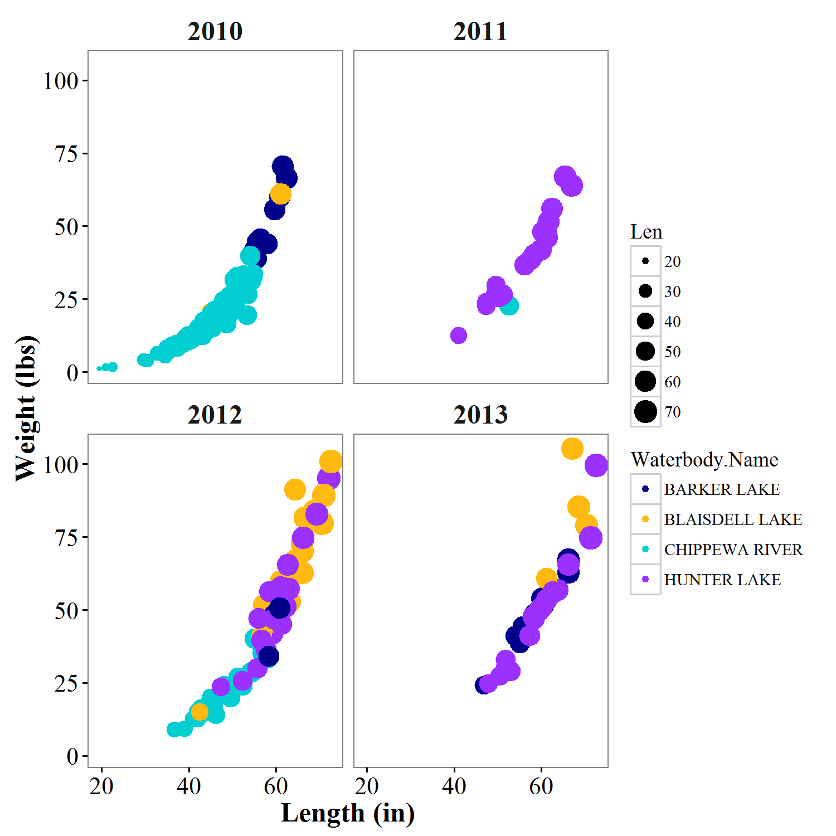

###################### Changing the legend ##############################

#3J Changing legend title

windows()

L_vs_W_year_waterbody<- L_vs_W_year_waterbody+

scale_colour_manual(name= "Name",values=c("blue4", "darkgoldenrod1", "darkturquoise", "purple1")) #set legend title within color scale

print(L_vs_W_year_waterbody)

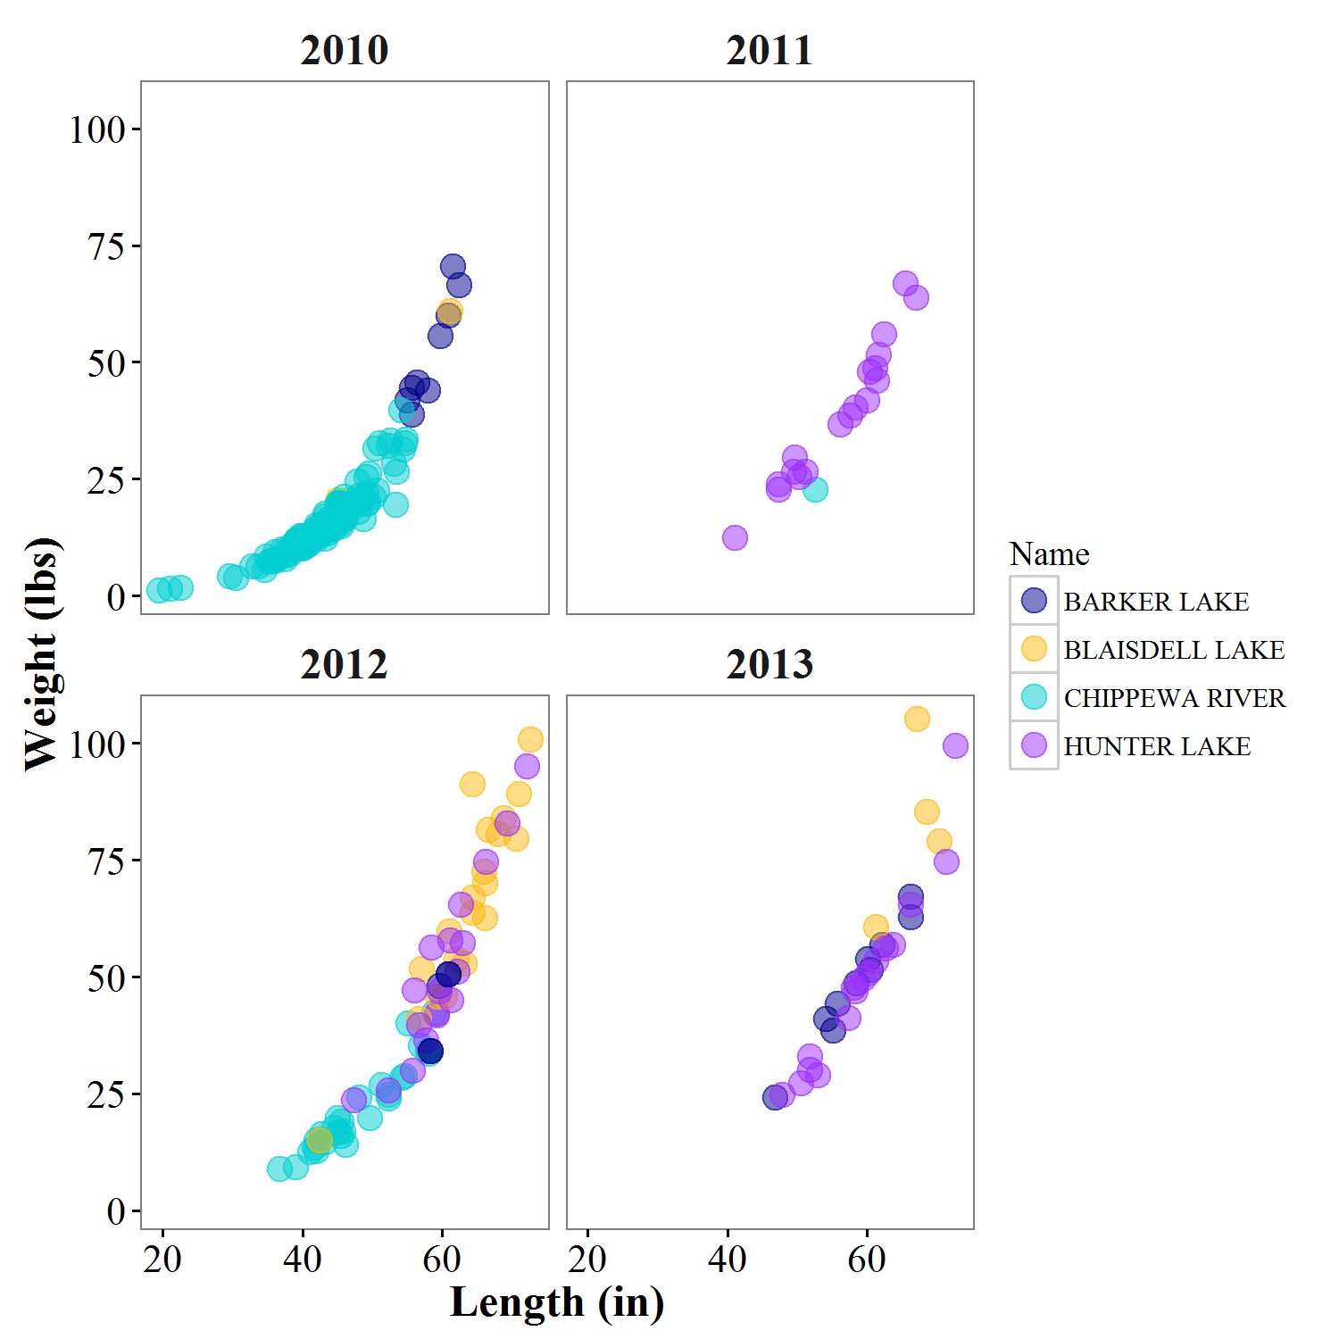

#3K Changing legend position

#using directional commands

windows()

L_vs_W_year_waterbody<- L_vs_W_year_waterbody+

theme(legend.position="bottom")

print(L_vs_W_year_waterbody)

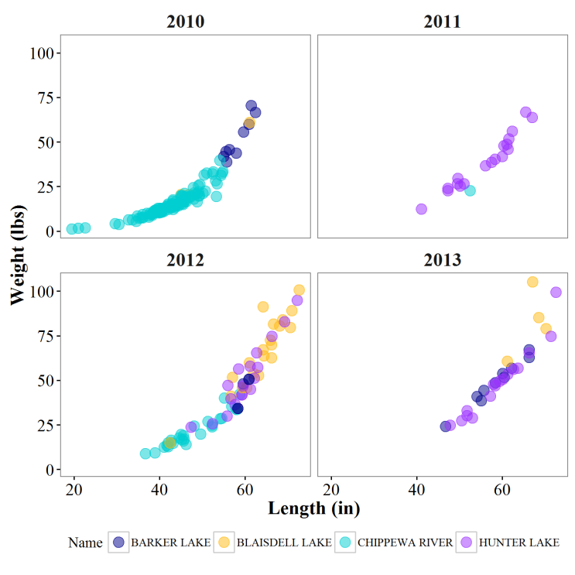

#using coordinates

windows()

L_vs_W_year_waterbody<- L_vs_W_year_waterbody+

theme(legend.position=c(.2,.85)) #coordinates are x,y, and indicate proportion of total length of axis

print(L_vs_W_year_waterbody)

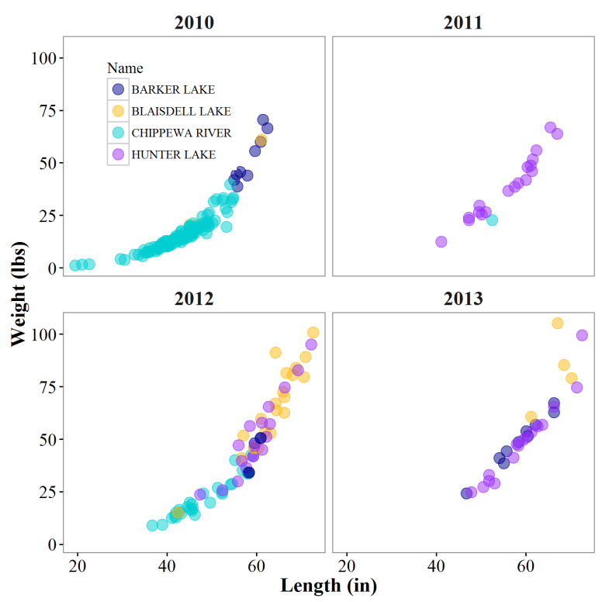

#3L changing appearance of legend - change legend font, remove boxes around dots, remove legend background, and

#make legend symbols bigger

windows()

L_vs_W_year_waterbody<- L_vs_W_year_waterbody+

guides(colour = guide_legend(override.aes = list(size=8))) + #this sets the size of legend points #independently

theme(legend.title=element_text(size=16, face="bold"),

legend.text=element_text(size=12),

legend.key = element_blank(), #this removes boxes around dots in legend

legend.background=element_blank() #this removes white fill from inside legend rectangle

)

print(L_vs_W_year_waterbody)

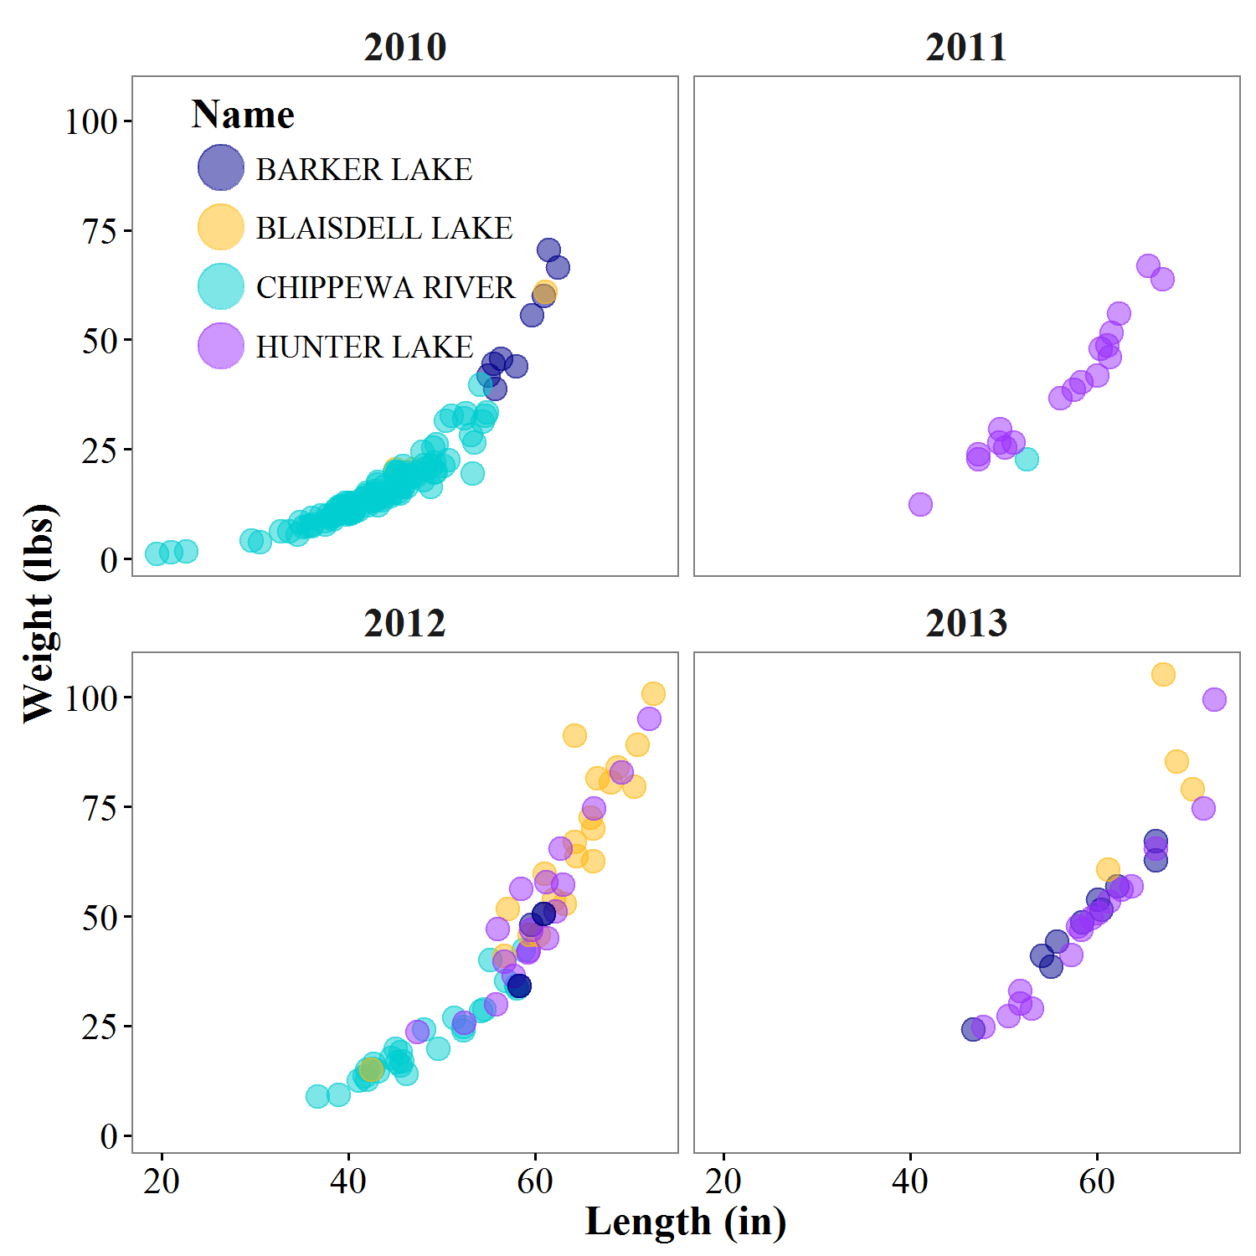

#3M turning legend off

windows()

L_vs_W_year_waterbody<- L_vs_W_year_waterbody+

theme(legend.position="none")

print(L_vs_W_year_waterbody)

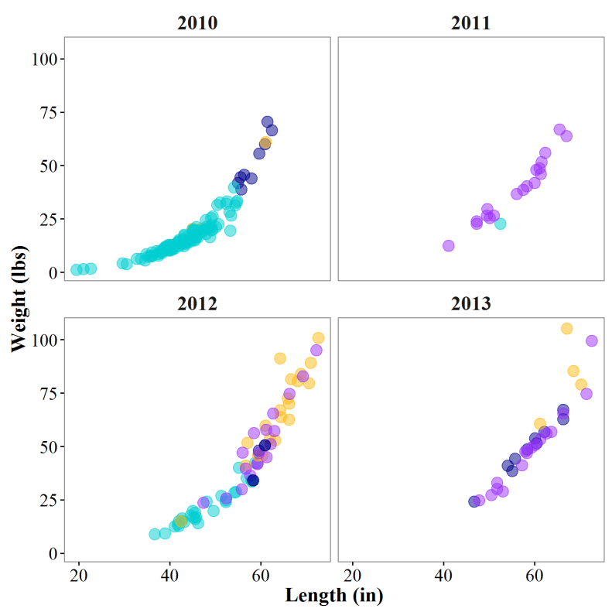

######################Saving your figure################################################

#3N save as png

ggsave('C:/Users/hanseg/Documents/R workshop/FM statewide March 2016/sturgeon_length_weights.png',

height=4, width=4, units='in', dpi=300)

#3O save as Tiff, compress file size

ggsave('C:/Users/hanseg/Documents/R workshop/FM statewide March 2016/sturgeon_length_weights.tiff',

height=4, width=4, units='in', dpi=300, compression="lzw")

#3p save as Tiff, change figure dimensions - this is too small for font size and point size!

ggsave('C:/Users/hanseg/Documents/R workshop/FM statewide March 2016/sturgeon_length_weights_too_small.tiff',

height=2, width=2, units='in', dpi=300, compression="lzw")

ASSIGNMENTS (or make whatever plot you want, using your own data)

#Assignment 1:

Using BaseR, make a 2x2 panel figure plotting Length Vs. Weight for all muskies sampled in Sawyer County for 2010-2014 (hint: look to 1b for subsets and 1c for plotting code).

#Assignment 2:

For 2014 data, use GGplot to plot length distributions for all panfish species sampled (hint, look to 2b for similar plots, but keep in mind you have to use facet_wrap()).

#Assignment 3:

Now, for the same subset of data, plot the same length distributions using geom_boxplot() (hint, don’t use facet_wrap() to plot by factor, use aes() in the ggplot() line).

#Assignment 4:

For length-weight scatterplots in 2e of the script, log transform both length and weight data and add a linear trendline (hint: use log() function to transform, and use stat_smooth() to add line similar to 2h only ‘method’ will be ‘lm’ instead of ‘loess’).

#Assignment 5:

Using the figure created in #4 above, remove major gridlines, minor gridlines, re-label the axes, and create a title (hint: 3b and 3c).

#Assignment 6:

Using the plot from figure 5 (or from 2e), change the color of each datapoint to represent the waterbody that the individual was sampled from. Now re-label the legend and change the color and size of the datapoints to your liking (hint: use 2e as a base figure and 3e and 3g for customizing datapoint aesthetics, and 3L for changing the legend).

#Assignment 7:

Now, print your figure as a PNG file to your desktop (hint: 3n)